SCHEDULE OF PRACTICAL CLASSES FOR GENERAL MEDICINE
1st SEMESTER 2012/2013.
LATIN LANGUAGE AND MEDICAL TERMINOLOGY

№ | Theme | h.
1 | Short history of the Latin language. The alphabet. Vowels and consonants. Pronunciation. Diphthongs. | 2
2 | The accent. Length and brevity of the syllable. | 2
3 | Review of the Latin Nouns. Declensions. Formation of anatomical terms (Sn-Sg). Introduction to the anatomical nomenclature. | 2
4 | Review of the Latin Adjectives. Two groups. Formation of anatomical terms (Sn-An). | 2
5 | Anatomical terms with different kinds of modifiers. Test. | 2
6 | The 1st declension of Nouns. The Greek Nouns of the 1st declension. Prepositions (Acc., Abl.) | 2
7 | The 2nd declension of Nouns. The masculine and neutral genders. | 2
8 | The 1st and 2nd declension Adjectives. | 2
9 | Test. | 2
10 | The 3rd declension of Nouns. General information. Three types of Nouns. | 2
11 | The 3rd declension of Nouns. The masculine gender. Exeptions. | 2
12 | The 3rd declension of Nouns. The feminine gender. Exeptions. | 2
13 | The 3rd declension of Nouns. The neutral gender. Exeptions. | 2
14 | The 3rd declension of Nouns. Irregular Nouns. | 2
15 | The 3rd declension Adjectives. | 2
16 | The degrees of comparison of Adjectives. | 2
17 | The 4th declension of Nouns. The 5th declension of Nouns. Exceptions. | 2
18 | Final Test. | 2
 | Total | 36

THEMATIC PLAN OF PRACTICAL LESSONS

for foreign students of medical phaculty
SUBJECT | Quantity of hours
1. Vowels and consonants (а, о, у, е, и, і, м, б,п, н, т, д, в, ф). The Noun. Intonation of declarative sentence. Consonants (с, з, ц, к, х, г, ѓ, р, л). Intonation of declarative sentence with conjunction А. Intonation of general and special question. The Noun. General notion about the number. | 4
2. Consonants (ш, ж, ч, щ, дз, дж). Sentences with interrogative words Хто? Що? Де? General notion about the gender of the noun. Personal pronouns він, вона, воно, вони. | 4
3. Consonant (й). Conjunction і (й). Letters я, ю, є, ї.. Particularity of their usage. Long consonants. The gender of the nouns of neuter gender. | 4
4. Personal and possessive pronouns. Interrogative pronoun Чий? Чия? Чиє? Чиї? | 6
5. The Verb. Conjugation I. Infinitive. Present tense. | 4
6. The Verb. Conjugation II. Present tense. Imperative Mood. The Accusative Case Denoting Direct Object. | 4
7. Conjugation of the Verbs купувати, працювати, робити, любити. Past Tense of the Verb. Verb БУТИ. The Verb. Future Tense. | 4
8. Adverb as Part of Speech which characterize the action. Adverbs of Time and Manner. Question ЯК? | 2
9. The Adjective. Gender and Number. Adjectives and possessive Pronouns in the Accusative Case Singular. Days of the Week. | 4
10. Animate Nouns and Personal Pronouns in the Accusative Case Singular. | 4
11. Adjectives and Possessive Pronouns in the Accusative Case Plural. | 4
12. The Verb. Perfective and Imperfective Aspect. | 6
13. Verbs of Motion іти, їхати. Tense and Aspect. | 6
14. Nouns in the Accusative Case after Verbs of Motion. Usage of the Prepositions У, НА. | 4
15. Verbs of Motion ходити, їздити and their Usage. | 4
16. The Noun. Locative Case of Place. Usage of the Prepositions У, НА. | 4
17. Nouns in the Locative Case Plural. | 2
18. Adjectives and possessive Pronouns in the Locative Case. | 6
19. Usage of Locative Case for Expression of Time (months, years). | 4
Total test checking of module 1 | 2
Total | 82

TOPICS LECTURE
Ukrainian language for students of the first course medical phaculty
2012-2013
 | SUBJECT | Quantity of hours
1. | Ukrainian language - the national language of the Ukrainian people. | 2
2. | The word as a unit of language. Nominative function of word (ручка - предмет, гарний - ознака, писати - дія, чотири - кількість). | 2
3. | Synonyms. Absolute synonyms (батько = тато, мама = мати, буква = літера). Antonyms (там ≠ тут, день ≠ ніч, швидко ≠ повільно, старий ≠ новий, працювати ≠ відпочивати). | 2
4. | Practical phonetics. Organs of speech and their work. Features playback and sound functioning of Ukrainian language. Loud sounds of modern literary Ukrainian. Artykulation-acoustic classification of consonants. Orthoepy. Pronunciation of vowels and consonants. | 2
5. | Graphics and spelling. Ukrainian alphabet. The relationship between letters and sounds of the Ukrainian alphabet in the Ukrainian language. | 2
6. | Parts of speech. The general value of the noun. Proper and common names. Category creatures and inanimate things. Grammatical categories of noun. Category of gender. Category of number. Category of case. The main meanings of a case. Conjugation of nouns. | 4
7. | Adjective. The meaning of adjectives. Qualitative adjectives. Relative Adjectives. Hard and soft groups of adjectives. Conjugation of adjectives. Agreement of the adjective with noun. | 4
8. | Pronoun. The meaning of pronouns. Correlation of pronouns to other parts of speech. Personal pronouns я (ми), ти (ви). Personal-pointing pronouns він,вона, воно, вони. Reflexive pronoun себе. Possessive pronouns мій (наш), / (ваш), свій (свої). Demonstrative pronouns цей, той, такий. Attributive pronouns (самий), весь (увесь), кожний (кожен). Interrogative-relative pronouns хто, що, який, чий, скільки, котрий. Conjugation of personal pronouns. | 4
9. | The verb. The meaning of the verb. Infinity. Two conjugations of verbs. Category of aspect. Imperfective and perfective verbs. Category of person. Category of tense. Present, future, past tense. Category of manner of action. Paradigm of imperative mood. | 6
10. | Adverbs. The meaning of adverb, its grammatical features. Quality-attributive adverbs (добре, швидко, повільно). Adverbs of manner (разом, по-українському / по-українськи). Quantitatively-attributive adverbs (дуже, багато). Adverbial moderfire of time (тепер, зараз, завжди). Impersonal-predicate adverbs expressing the state of nature (тихо, тепло, холодно). | 2
11. | The numeral. The meaning of the numerals.Quantitative and ordinal numerals. | 2
12. | Preposition. Use of prepositions у (в), на, з (із, зі), про, до with nouns in different cases. Conjunction. Coordinating conjunctions і (й), та (in the sense і). Disjunctive conjunctions або, чи. Adversative conjunctions а, але | 4
 | Total | 36

THEMATIC AND CALENDAR SCHEDULE OF MEDICAL BIOLOGY COURSE LECTURES, PRACTICES, INDEPENDENT WORKS IN THE 2012-2013 ACADEMIC yEAR FOR STUDENTS OF MEDICAL FACULTY (eNGLISH MEDIUM)

MODULE 1. Biological features of human vital activity

Content module 1. “Molecular-cellular level of life organization”

The themes of lectures
№ | Topic | Hours | Date
1. | Introducing to Medical Biology. A cell as elementary morpho-functional biological unit. | 2 | 3.09-14.09
2. | Molecular bases of heredity. Realization of hereditary information. | 2 | 17.09-28.09
3. | Cells level of reproduction. | 2 | 1.10-12.10
 | Total | 6

The themes of practical classes
№ | Topic | Hours | Date
1 | Levels of living matter organization. Optical systems in biological investigations. | 2 | 3.09-7.09
2 | Cell membranes. Transport across the cell surface membrane (plasmolemma). | 2 | 3.09-7.09
3 | Cell morphology. Structural components of cytoplasm. | 2 | 10.09-14.09
4 | Chromosomes morphology. Human karyotype. | 2 | 10.09-14.09
5 | Characteristic of nucleic acids. The organization of the information flow in cell. | 2 | 17.09-21.09
6 | Genes structure in pro- and eukaryotes. Structural and regulatory genes. Processes of genetic information realization. | 2 | 24.09-28.09
7 | Cell cycle. Mitosis. | 2 | 1.10 -5.10
8 | Reproduction – the basic property of living matter. Meiosis. | 2 | 8.10-12.10
9 | Control of the module 1 | 2 | 15.10-19.10
 | Total | 18
The themes for independent work
№ | Topic | Hours
1 | Preparing for practical classes – theoretical preparing and practical experience. | 2
2 | Topics, which are not included to the plan of academic practical classes.
2.1 | The organization of the way of biological things and energy in cell. | 1
2.2 | Life of the cell outside the organism. Cell cloning. | 1
3 | Preparing of the control of the learning module 1 | 2
 | Total | 6

MODULE 2. Organism level of organization of the alive. Basis of human genetics
Content module 2. “Basic principles of heredity and variability”

The themes of lectures
№  з/п | Topic | Hours | Date
4. | Organism level of the genetic information organization. Gene’s interaction. | 2 | 15.10-26.10
5. | Chromosomal theory of heredity. Sex genetics. | 2 | 29.10-9.11
6. | Variation in human as life property and genetic phenomenon. | 2 | 12.11-23.11
Total |  | 6

The themes of practical classes
№ | Topic | Hours | Date
10 | Human Genetics peculiarity. Heredity laws and traits expression in Human organism (monohybrid and polyhybrid inheritance). | 2 | 22.10-26.10
11 | Allelic and non-allelic gene’s interactions. Phenomena of pleiotropy. | 2 | 29.10-2.11
12 | Linkage inheritance. Sex genetics. Sex-linked inheritance. | 2 | 5.11-9.11
13 | Chromosomal theory of heredity. Linkage of gene’s. Crossing-over. | 2 | 12.11-16.11
Total |  | 8

The themes for independent work
№ | Topic | Hours
1 | Preparing for practical classes – theoretical preparing and practical experience. | 3
2 | Topics, which are not included to the plan of academic practical classes.
2.1 | Genetic maps. Methods of the human chromosomes mapping. Current state of human genome investigation. | 1
2.2 | Genetic dangerous of environment contamination. Conceptions about antimutagenes and comutagens. | 1
Total |  | 5

Content module 3. “Methods of the human inheritance investigation. Hereditary diseases”

The themes of lectures
№ | Topic | Hours | Date
7. | The basic principles of human genetics. Methods of the human inheritance investigation. | 2 | 26.11-7.12
8. | Genetic disorders of human. | 2 | 10.12-21.12
Total |  | 4

The themes of practical classes
№  з/п | Topic | Hours | Date
14 | Variability of the organisms, its forms. Phenotypic and genotypic variation. | 2 | 19.11-23.11
15 | The basic principles of medical genetics. Gene’s and chromosomal diseases. Cytogenetics and biochemical analysis of the human being. | 2 | 26.11-30.11
16 | Study of twins. Genealogy of human as the method of human inheritance investigation. | 2 | 3.12-7.12
17 | Dermatoglyphics as the method of human inheritance investigation. Genetic characters of human populations (Hardy-Weinberg law). | 2 | 10.12-14.12
18 | Practical skills of content modules 2 and 3. | 2 | 17.12-21.12
Total |  | 10

The themes for the independent work
№ | Topic | Hours
1 | Preparing for practical classes – theoretical preparing and practical experience. | 3
2 | Topics, which are not included to the plan of academic practical classes.
2.1 | Gene engineering. Biotechnology. Gene therapy. | 1
2.2 | Methods of human genetics: dermatogliphics, immunologic, somatic cells hybridization. | 1
3 | Practical skills of content modules 2 and 3. | 3
 | Total | 8

Content module 4. “Biology of individual development”

The themes of lectures
№ | Topic | Hours | Date
9. | Molecular and genetic mechanisms of ontogenesis. Breaks of the ontogeny and their place in human pathology. | 2 | 24.12-28.12
10. | Modern aspects of regeneration and transplantation. Biological mechanisms of homeostasis of the organism. | 2 | 10.01-14.01
Total |  | 4

The themes of practical classes
№ | Topic | Hours | Date
19 | Peculiarities of prenatal period of human development. | 2 | 24.12-28.12
20 | Postnatal period of human development | 2 | 10.01-16.01
21 | Aging as the finishing stage of human ontogeny. Theories of ageing. | 2 | 10.01-16.01
22 | Control of the module 2 | 2 | 17.01-23.01
Total |  | 8

The themes for the independent work
№ | Topic | Hours
1 | Preparing for practical classes – theoretical preparing and practical experience. | 2
2 | Topics, which are not included to the plan of academic practical classes.
2.1 | The notion about aura, biological rhythms and their medical importance. | 1
2.2 | Regeneration and its types: physiological and reparative. Levels and ways of regeneration. | 1
3 | Preparing of the control of the learning module 2 | 3
 | Total | 7
II semester

MODULE 3 "Population-species, biogeocenotic and biospheric levels of life organization"

Content module 5. “Medical and Biological Basis of Parasitism. Medical Protozoology”

The themes of lectures
№ | Topic | Hours | Date
11 | The medical biological bases of parasitism. Protozoa are human parasites. | 2
Total |  | 2

The themes of practical classes
№ | Topic | Hours | Date
23 | Medical Protozoology. Phylon Sarcomastigophora, Classis Lobozea. Phylon Ciliophora. Classis Rimostomatea. | 2
24 | Representatives of the Classis Zoomastigophora – human parasites. | 2
25 | Phylon Apicomplexa. Representatives of the Classis Sporozoa – human parasites. | 2
Total |  | 6

The themes for the independent work
№ | Topic | Hours
1 | Preparing for practical classes – theoretical preparing and practical experience. | 2
2 | Preparing of themes, which don’t in plan of auditory classes.
11 | Methods of laboratory diagnosis of diseases caused by protozoa parasites. | 1
 | Total | 3

Content module 6. “Medical Helminthology”

The themes of lectures
№ | Topic | Hours | Date
12 | Medical Helminthology. Flat and nematode worms are human parasites. | 2
Total |  | 2

The themes of practical classes
№ | Topic | Hours | Date
26 | Phylon Plathelmintes. Classis Trematoda: Trematodes of the liver and lancet-like. | 2
27 | Classis Trematoda: Intestinal Trematodes, Trematodes of the lungs, Trematodes of the blood. | 2
28 | Classis Cestoidea: beef tapeworm, pork tapeworm, dwarf tapeworm. | 2
29 | Classis Cestoidea: Echinococcus, Alveococcus, broad tapeworm (fish tapeworm). | 2
30 | Phylon Nemathelminthes. Classis Nematoda: large intestinal roundworm, pinworm (seatworm), whipworm. | 2
31 | Phylum Nemathelminthes. Classis Nematoda: Ancylostoma duodenale, Strongiloides stercoralis, Trichinella spiralis. | 2
32 | Practical skills of content modules 5 and 6 “Medical Protozoology’’ and “Medical Helminthology” | 2
Total |  | 14

The themes for the independent work
№ | Topic | Hours
1 | Preparing for practical classes – theoretical preparing and practical experience. | 4
2 | Preparing of themes, which don’t in plan of auditory classes.
2.1 | Blood flukes. Agents of metagonimosis and nanophoetosis. | 1
2.2 | Guinea worm (Dracunculus medinensis) and Filaria – agents of diseases. | 1
3 | Practical skills of content modules 5 and 6 | 3
 | Total | 9

Content module 7. “Medical Arachnoentomology”

The themes of lectures
№ | Topic | Hours | Date
13 | Medical Arachnoentomology. Arthopods as the carriers of human infections and invasions. | 2
Total |  | 2

The themes of practical classes
№ | Topic | Hours | Date
33 | Phylon Arthropoda. Classis Arachnoidea. Ticks (Acarina) – the carriers of human infections and invasions | 2
34 | Classis Insecta: Diptera – the carriers of human infections and invasions | 2
35 | Classis Insecta: lise and fleas – the carriers of human infections and invasions. | 2
Total |  | 6

The themes for independent work
№  з/п | Topic | Hours
1 | Preparing for practical classes – theoretical preparing and practical experience. | 3
2 | Preparing of themes, which don’t in plan of auditory classes.
2.1 | Ticks and mites of human home or apartment and their medical importance. | 0,5
2.2 | Medical importance of blood sucking insects: characters, importance as the intermediate hosts of helminthes and carriers of human infections. | 0,5
 | Total | 4

Content module 8. “Correlation between individual and historical development of the organism. Biosphere and human population”
The themes of lectures
№ | Topic | Hours | Date
14 | Phylogenesis of main organ systems of Vertebrates. Ontophylogenetic reasons for developmental defects. | 2
15 | Synthetic theory of evolution. Peculiarities of evolutionary factors action in human population. Biosphere as a system supporting human being. | 2
Total |  | 4

The themes of practical classes
№ | Topic | Hours | Date
36 | Phylogenesis of main organ systems of Vertebrates (the cardiovascular systems system). Ontophylogenetic reasons for developmental defects. | 2
37 | Phylogenesis of main organ systems of Vertebrates (the excretory system). Ontophylogenetic reasons for developmental defects. | 2
38 | Biosphere as a system which keeps up global existence of mankind. Human ecology. | 2
39 | Synthetic theory of evolution. Population structure of mankind. | 2
40 | The control of the learning of the module 3 | 2
Total |  | 10

The themes for the independent work
№ | Topic | Hours
1 | Preparing for practical classes – theoretical preparing and practical experience. | 3
2 | Preparing of themes, which don’t in plan of auditory classes.
2.1 | Origin of human. Human races as the reflects of developmental adaptation. | 2
22 | Poisonous plants and animals | 2
3 | Practical skills of content module 3 | 3
Total |  | 10

Plan of lectures of the course of “Medical and Biological Physics”for first-year medical students in the first semester of 2012/2013 academic year (The module 1 “Mathematical processing of medical and biological information”,the module 2 “Basics of Biological Physics”and the module 3 “Basics of Medical Physics”)

№ | Topics | Class  duration  (hours) | Date
1. | Introduction. Elements of probability theory. | 2 | 05.09
2. | Elements of mathematical statistics. | 2 | 19.09
3. | Elements of biomechanics and bioacoustics. | 2 | 03.10
4. | Principles of biological rheology. Physical principles of hemodynamics. | 2 | 17.10
5. | Thermodynamics of open biological systems. | 2 | 31.10
6. | Membranes. Mechanisms of transport of no-charged and charged particles through biological membranes. | 2 | 14.11
7. | Biological potentials. Resting membrane potential. Generation and propagation of action potential. | 2 | 28.11
8. | Electric and magnetic behavior of biological tissues. Physical basics of rheography and high-frequency electrotherapy. | 2 | 12.12
9. | Physical basics of tissues and organs electrography. | 2 | 26.12
In total |  | 18

Plan of laboratory and practical classes of the course of “Medical and Biological Physics” for first-year medical students in the first semester of 2012/2013 academic year

№ | Topics | Class  duration  (hours)

Module 1.

Mathematical processing of medical and biological information
1 | Basics of differential calculus. | 3
2 | Basics of integral calculus. | 3
3 | Concept of differential equations. | 3
4 | Elements of the theory of probability. | 3
5 | Elements of mathematical statistics.  Laboratory work. Analysis of distribution of investigated criterion and determination of statistical characteristics. | 3
6 | Final module № 1 (topics 1-5). | 3
Module 2.
Basics of biophysics
7 | Elements of biomechanics.  Laboratory work. Determination of coefficient of elasticity of bone tissue. | 3
8 | Elements of biophysics of hearing.  Laboratory work. Study of spectral characteristic of the ear on the hearing threshold. | 3
9 | Infrasound. Ultrasound. Vibrations.  Laboratory work. Study of parameters of biological objects by ultrasound location method. | 3
10 | Principles of biorheology.  Laboratory work. Determination of the coefficient of viscosity of liquid by capillary viscosimeter. | 3
11 | Principles of hemodynamics.  Laboratory work. Physical principles of investigation of hemodynamics parameters. | 3
12 | Laboratory-practical class. Study of principles of thermodynamics of opened biological systems. | 3
13 | Elements of biophysics of membrane processes.  Laboratory-practical class. Study of structure and functions of biological membranes. | 3
14 | Laboratory-practical class. Study of mechanisms of resting and action membrane potentials generation. | 3
15 | Final module № 2 (topics 7-14). | 2
In total |  | 44

Self-study plan

of the course of “Medical and Biological Physics” for first-year medical students in the first semester of 2012/2013 academic year

Module 1 Mathematical processing of medical and biological information

№ | Topics
1. | To become proficient in calculation of derivatives of simple and compound functions.
 | To become proficient in differentiation of function of one variable, partial derivatives and differentials of function of two and more variables and complete differential.
2. | To become proficient in method of integration by substitution and by parts.
3. | To become proficient in solving of differential equations.
4. | To become proficient in using of theorems of addition and multiplication of probabilities for tasks solution.
5. | To learn how to use the methods of mathematical statistics for solution of medical-biological tasks.
 | Preparation for written test.
 | Individual work – preparation of scientific literature review.
 | In total – 8 hours for self-study

Module 2 Basics of Biological Physics
6. | To learn haw to explain undamped and damped vibrations in biological systems.
7. | To become proficient in working with clinical audiometer.
 | To estimate and interpret the results of study of spectral sensitiveness of the ear on the hearing threshold.
8. | To become proficient in the interpreting of diagrams of extension and compression and in determination of main parameters of tissues elastic properties.
9. | To become proficient in determination of coefficient of surface tension.
10. | To become proficient in determination of viscosity coefficient of liquids.
11. | To familiarize oneself with rheology properties of blood.
12. | To become familiar with thermodynamics method of study of medical-biological systems.
 | To become familiar with biophysical principles of reception (visual reception).
13. | To explain the nature of generation of concentration potential.
14. | To become proficient in making of electric circuit and determination of electromotive force of concentration element by compensative method.
15. | To become proficient in working with the computer program and to study the change of action potential.
 | Preparation for tests (module 2).
 | Individual work – preparation of review of scientific literature in the abstract form (one of mentioned below items).
 | In total – 24 hours for self-study

CALENDAR AND THEMATIC SCHEDULE OF LECTURES
on medical chemistry for the 1st year students of medical faculty
during the autumn term of 2012 – 2013 academic year
Groups 4-13
To p i c s a n d c o n t e n t s o f l e c t u r e s Number
Date of hours
Module 1
12.09 Solutions. Ways of expressing concentrations of solutions. Colligative
properties of solutions. Osmosis, osmotic pressure. 2
26.09 Coordination compounds, their classification and properties. Chelates.
Complexonometry.
2
10.10 The chemistry of bioelements. Classification of bioelements, their
biochemical role and medical uses.
2
24.10
The self-ionization of water. The pH. Buffer solutions. The mechanism of
buffer action. The quantitative characteristics of buffer systems. Buffer
systems of blood. The acid - base equilibrium of biological liquids.
2
Module 2
07.11
The theoretical basis of bioenergetics. The use of thermodynamic functions
for energetic characteristic of biochemical processes. The criteria of
spontaneous course of chemical processes.
2
21.11 The principal laws of the biochemical processes passing. 2
05.12 The electrodes potentials and driving forces, their biological role and
application in medicine.
2
19.12 Physics and chemistry of the surfaces phenomenon. The bases of the
adsorption therapy. Chromatography.
2
16.01 Colloid solutions. Dialysis, gel-filtration. 2
23.01 Physical and chemical properties of the biopolymers solutions. 2
Totally:20

CALENDAR AND THEMATIC SCHEDULE
of practice and laboratory studies in medical chemistry
for the 1st year students of medical faculty during the autumn term of 2012 – 2013 academic year
Groups The topics Number
of
hours
4-6 7-8 9-10, 13 11-12
Date
Module 1 “Acid-Base Equilibrium and the Processes of Coordination Compounds Formation in Biological Liquids”
Thematic module 1
03.09 06.09 05.09 07.09
Solutions and their concentrations. Preparation the solution with
known concentration
2.5
10.09 13.09 12.09 14.09
Colligate properties of solutions. Experimental determination of
the osmotic concentration of solutions with the kriometry method
2.5
17.09 20.09 19.09 21.09
The equilibrium and processes with coordination (complex)
compounds. Preparation and properties of complex and inner
complex compounds. Complexonometry
2.5
24.09 27.09 26.09 28.09
Bioelements and their classification. Chemical properties and
biological role of macroelements
2.5
01.10 04.10 03.10 05.10 Chemical properties and biological role of microelements 2.5
Thematic module 2
08.10 11.10 10.10 12.10
Acid-base equilibrium. Calculation and experimental
determination of the рН of solutions
2.5
15.10 18.10 17.10 19.10 Protolytical processes in living organisms. The hydrolysis of salts 2.5
22.10 25.10 24.10 26.10
Buffer solutions, their classification and the mechanism of the
buffer action. Preparation of buffer solutions. Determination of
the buffer capacity and the pH values of buffer solutions. The
biological role of buffer systems
2.5
29.10 01.11 31.10 02.11
The basic principles of the volumetric analysis. Acid-base
titration. Determination of the acidity of stomach liquid
2.5
05.11 08.11 07.11 09.11
The final control of the acquirement the Module 1 “Acid-Base
Equilibrium and the Processes of Coordination Compounds
Formation in Biological Liquids”
2.5
Module 2 “The equilibrium in biological systems on the boundary of phases division”
Thematic module 3
12.11 15.11 14.11 16.11
Energetics of chemical reactions and processes. Calculations
according thermochemical equations and experimental
determination of heat effects of chemical processes. Bioenergetics
2.5
19.11 22.11 21.11 23.11
Kinetics of chemical reactions. The chemical equilibrium.
Solubility product constant
2.5
26.11 29.11 28.11 30.11
Measuring the electromotive forces of galvanic cells and
electrode potentials
2.5
03.12 06.12 05.12 07.12
The reduction-oxidation potentials measuring. Potentiometry
determining of pH for solutions and biological liquids.
Potentiometry titration
2.5
Thematic module 4
10.12 13.12 12.12 14.12
The surface tension and surface-active substances. Adsorption on
the movable interfaces
2.5
17.12 20.12 19.12 21.12
Adsorption on the immovable interfaces. The adsorptive ability of
activated charcoal studying. Ions-exchange adsorption and
chromatographic methods of analysis
2.5
24.12 27.12 26.12 28.12 Lyophobic sols preparation and their properties studying 2.5
14.01 10.01 16.01 11.01
The stability of colloidal systems. Coagulation and colloidal
protection
2.5
21.01 17.01 23.01 18.01
High molecular compounds. The determination of the swelling
degree of gels and the influence of different factors on it. The
determining of isoelectric point of proteins.
2.5
24.01 24.01 24.01 24.01
The final control of the acquirement the Module 2 “The
equilibrium in biological systems on the boundary of phases
division”
2.5
Totally:50

Plan of the lectures of human anatomy for the students

of medical faculty in 1st semester

of 2012/2013 studying year

№ | Topic | Hours
 |  | 1 - 2 | 3 | 4 – 13
1. | Introduction. | 04.09 | 11.09 | 10.09
2. | Development of the human embryo. Germ layers and their  derivates | 18.09 | 25.09 | 24.09
3. | General osteology | 02.10 | 09.10 | 08.10
4. | General arthrology | 16.10 | 23.10 | 22.10
5. | General myology | 30.10 | 06.11 | 05.11
 |  | 10

Plan of the practices of human anatomy for the students

of medical faculty in 1st semester of 2012/2013 studying year

№ | Topic | Hours
 |  | 1 – 4;  5 – 8 | 9-10 | 11– 13
1. | Anatomical terminology. Fundamental planes and axes in the body. General features of the vertebrae. Cervical, thoracic and lumbar vertebrae. Sacrum, coccyx, ribs, sternum | 07.09 | 06.09 | 05.09
2. | Frontal, parietal, occipital, ethmoidal bones | According to depart, schedule
3. | Sphenoid bone, temporal bone. Canals of temporal bone | 14.09. | 13.09 | 12.09
4. | Bones of the face. Orbit. Nasal cavity | 21.09 | 20.09 | 19.09
5. | External and internal base of the skull. Temporal fossa, infratemporal fossa, pterygopalatine fossa | According to depart, schedule
6. | Bones of the upper limb | 28.09 | 27.09 | 26.09
7. | Bones of the lower limb | 05.10 | 04.10 | 03.10
8. | Summary lesson: “Osteology” | According to depart, schedule
9. | Articulations of the thorax and vertebral column. Articulations of the skull | 12.10 | 11.10 | 10.10
10. | Articulations of upper limb | 19.10 | 18.10 | 17.10
11. | Articulations of lower limb | According to depart, schedule
12. | Summary lesson: “Bones and their articulations” | 26.10. | 25.10 | 24.10
13. | Muscles and fasciae of the back | 02.11 | 01.11 | 31.10
14. | Muscles and fasciae of the chest. Diaphragm | 09.11 | 08.11 | 07.11
15. | Muscles and fasciae of th abdominal wall. Rectus sheath. Inguinal canal | 16.11 | 15.11 | 14.11
16. | Muscles and fasciae of the head | 23.11 | 22.11 | 21.11
17. | Muscles and fasciae of the neck. Topography of the neck | 30.11 | 29.11 | 28.11
18. | Muscles of the upper limb | 07.12 | 06.12 | 05.12
19. | Fasciae and topography of the upper limb | 14.12 | 13.12 | 12.12
20. | Muscles of the lower limb | 21.12 | 20.12 | 19.12
21. | Fasciae and topography of the lower limb | 28.12 | 27.12 | 26.12
22. | Summary lesson: “Myology” | According to depart, schedule
23. | Total check of module 1 “Locomotor system” | 11.01 | 10.01 | 16.01
 |  | 69.

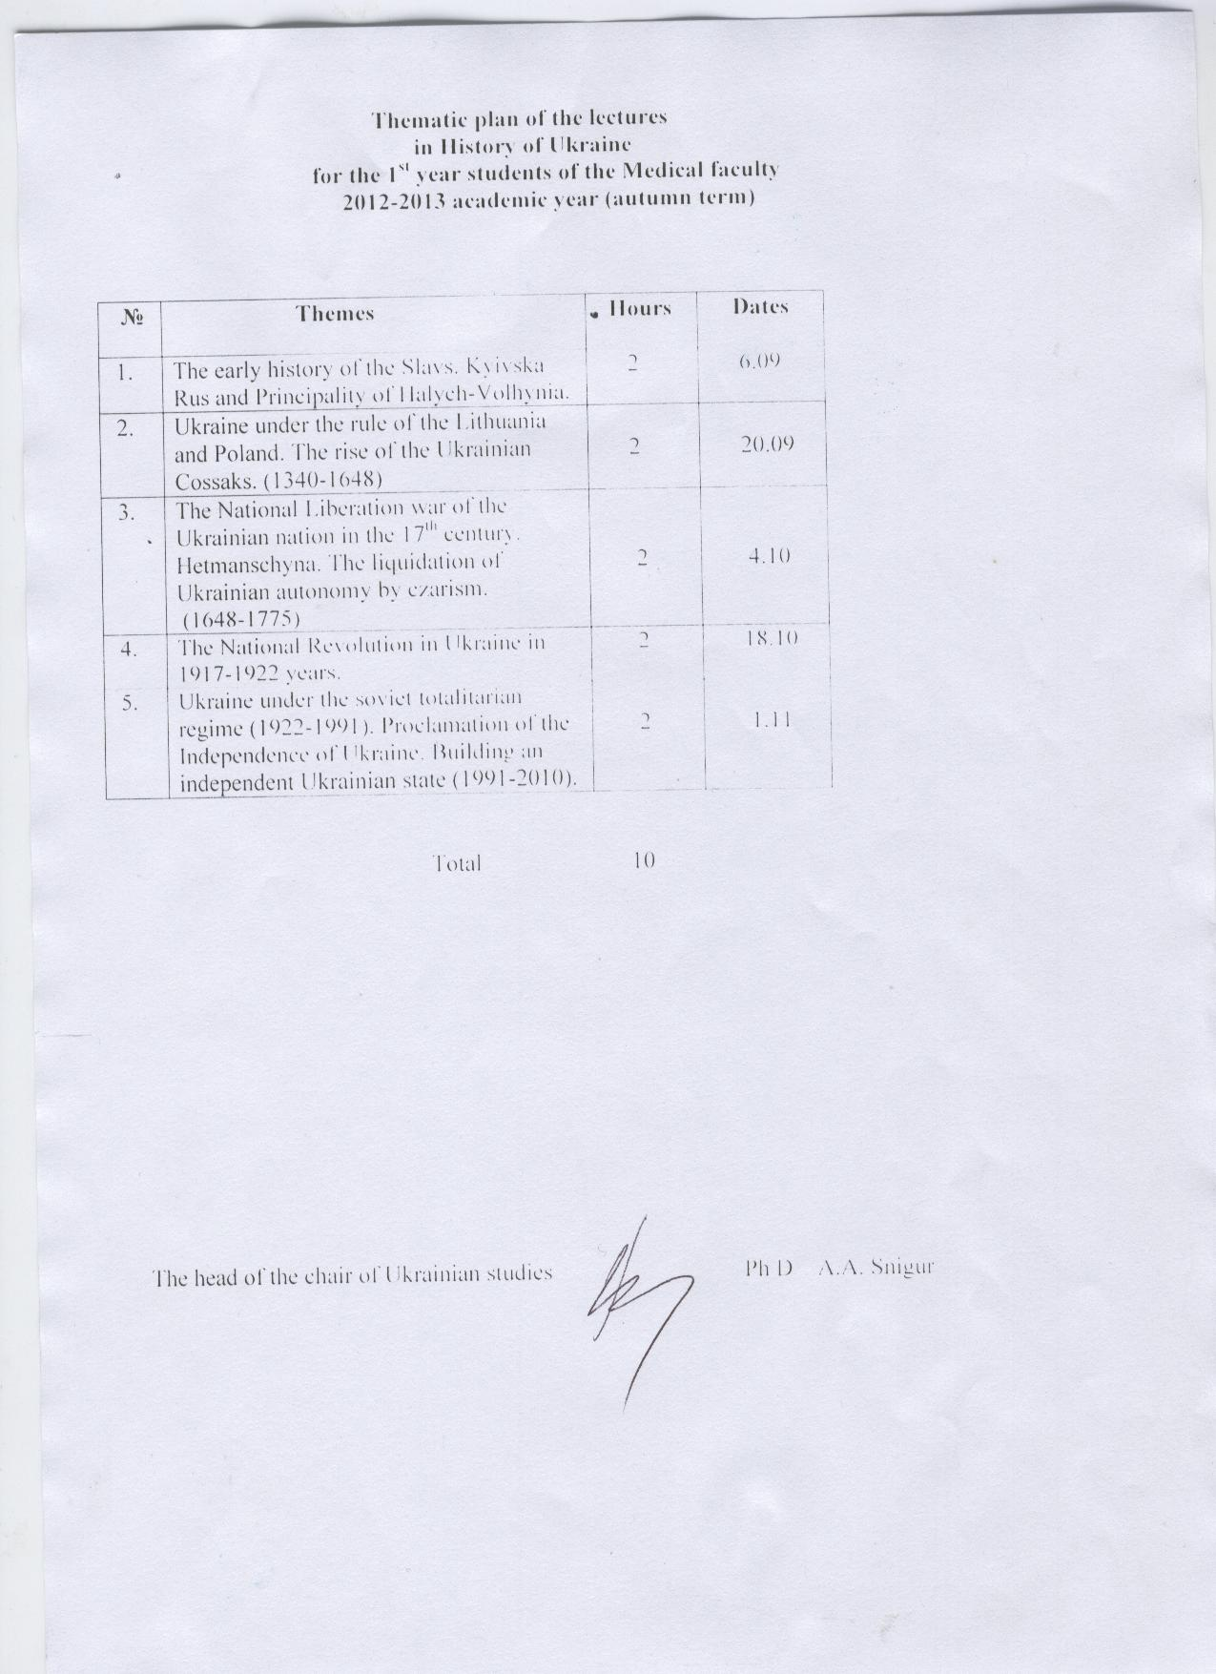

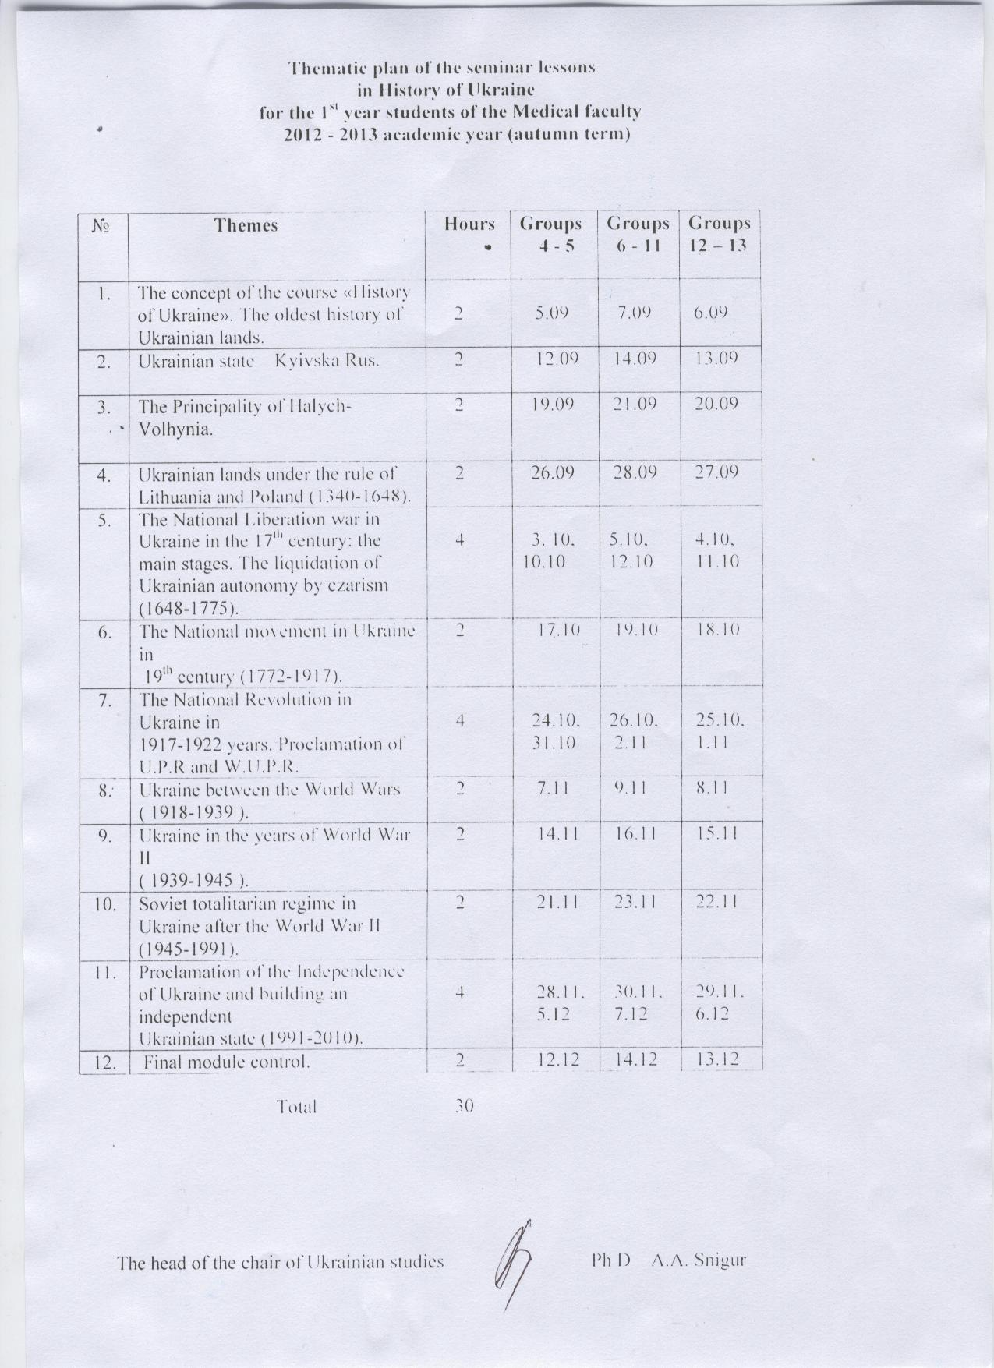 Thematic plan workshops for the English medium students 1 – st of courses
of medical faculty on the 20__/ 20__ academic years

№ Number  п/п Serial | Тема Subject | Кількість годин Hours
Змістовий модуль 1. A semantic module. Оволодіння основними засобами розвитку гнучкості, спритності та швидкості. Learn the basic features of flexibility, agility and speed.
1. 1. | Оволодіння основними засобами розвитку гнучкості. Вправи на розтягування м'язів, сухожиль та суглобових зв'язок із збільшеною амплітудою рухів, яка повільно збільшується; вправи із збільшенню амплітудою руху за допомогою партнера, з залученням ваги та ін. Mastering the basic means of flexibility. Exercises stretch muscles, ligaments and articular contact with a larger amplitude movements that slowly-increasing exercises with increasing amplitude of motion with a partner, with the assistance of gravity and so on. Анатомо-біомеханічні характеристики гнучкості. Anatomic and biomechanical characteristics of flexibility. | 2 2
2. 2. | Методи розвитку гнучкості та рухомості в суглобах та їх контроль. Methods of flexibility and mobility in the joints and their control. Основні групи вправ для розвитку гнучкості. The main groups of exercises to develop flexibility. Повільні рухи. Махові рухи. Slow motion. Makhov movements. Пружні рухи. Elastic movements. Згинання, розгинання, приведення, обертання, ціркумдукція, пронація, інверсія, реверсія. Flexion, extension, reduction, rotation, tsirkumduktsiya, pronation, inversion, reversion. Самоконтроль. Self-control. Визначення рівня фізичної підготовленості. Determining the level of physical preparation. | 2 2
3. 3. | Оволодіння основними засобами розвитку спритності. Методи розвитку спритності та їх контроль. Mastering the basic means of dexterity. Methods of dexterity and control. | 2 2
4. 4. | Оволодіння основними засобами розвитку спритності. Застосування вправ з швидкою зміною рухової діяльності, виконання різних вправ в незвичайних поєднаннях, зміна способів виконання вправ, зміна кінетичних та динамічних характеристик руху та ін. Mastering the basic means of dexterity. Application exercises with a quick change of motor activity, performance of various exercises in unusual combinations, change the way exercise, change of kinetic and dynamic characteristics of movement and others. | 2 2
5. 5. | Характеристика фізичних вправ, які застосовуються для розвитку спритності. Characteristics of exercise used to develop agility. Самоконтроль. Self-control. Визначення рівня підготовленості. Determining the level of preparedness. | 2 2
6. 6. | Оволодіння основними засобами розвитку швидкості. Спеціально-підготовчі та змагальні вправи, які виконуються з максимальною швидкістю на коротких відрізках дистанції, швидкісно-силові вправи, рухливі та спортивні ігри. Mastering the basic means of speed. Specially-competitive training and exercises are performed with maximum speed over short intervals of distance, speed, power exercises and outdoor sports. Анатомо-фізіологічні та біохімічні характеристики швидкості. Самоконтроль. Anatomic and physiological and biochemical characteristics of speed. Self-control. Визначення рівня підготовленості. Determining the level of preparedness. | 2 2
7. 7. | Види швидкості. Types of speed. Загальна швидкість. General speed. Спеціальна швидкість. Special rate. Методи розвитку швидкості та їх контроль. Техніку бігу на короткі дистанції – спринтерський біг. Methods of speed and control. Technics races over short distances - sprynterskyy run. Методика оволодіння технікою бігу. Methods of acquiring vehicles running. Характерні помилки при бігові і засоби їх виправлення. Typical mistakes in running and means to correct them. | 2 2

Змістовий модуль 2. Semantic module 2. Оволодіння основними засобами розвитку сили та витривалості. Mastering the basic means of strength and endurance.
8. 8. | Оволодіння основними засобами розвитку силових якостей. Learn the basic tools of law enforcement skills. Вправи з використанням власної ваги тіла і окремих його частин. Practice using your own body weight and some of its parts. Вправи з використанням ваги партнера та з її протидією, з протидією пружних предметів, з використанням гімнастичних снарядів та тренажерів. Exercises using weights and partner with its opposition, to counteract elastic objects, using apparatus and simulators. Ізометричні (статичні) вправи. Isometric (static) exercise. Абсолютна сила. Absolute power. Відносна сила. The relative strength. | 2 2
9. 9. | Анатомо-фізіологічні та біомеханічні характеристики силових якостей. Anatomic-physiological and biomechanical characteristics of power qualities. Форми і типи м'язових скорочень. Forms and types of muscle cuts. Нервова регуляція. Nervous control. Психофізіологічні механізми. Psychophysiological mechanisms. Функціональні резерви сили. Functional reserves of strength. | 2 2
10. 10. | Методи розвитку силових показників, та їх контроль. Methods of power indices and their control. Дозування. Інтенсивність. Dosage. Intensity. Динамічні навантаження з постійним опором. Dynamic loading with a constant resistance. Статичне тренування. Ізокинетичне тренування. Static training. Izokynetychne workout. Ексцентричне тренування. Bizarre training. Оцінка силових можливостей. Силовий фітнес-тренінг. Estimation of power. Power fitness training. Атлетична гімнастика. Athletic exercises. | 2 2
11. 11. | Оволодіння та удосконалення техніки вправ на тренажерах. Learn techniques and exercises to improve the bikes. Оволодіння основними дозування фізичних вправ при застосуванні атлетичних тренажерів для розвитку окремих груп м'язів. Learn basic exercise dosage in the application of athletic trainers for the development of specific muscle groups. | 2 2
12. 12. | Особливості техніки легкоатлетичних стрибків. Features track jumping technique. Оволодіння та удосконалення техніки легкоатлетичних стрибків. Learn and improve technology track jumping. Основи тренування в стрибкових видах легкої атлетики. Basics of training in athletics hopping types. | 2 2
13. 13. | Оволодіння основними засобами розвитку витривалості. Вправи, що спрямовані на розвиток анаеробних можливостей. Mastering the basic means of endurance. Exercises aimed at the development of anaerobic capacity. Циклічні вправи (ходьба, біг, ходьба на лижах, біг на ковзанах, плавання тощо), що виконуються до втоми, рівномірним та інтервальним методами в аеробному та змішаному режимах, які спрямовані на розвиток аеробних можливостей. Cyclic exercise (walking, running, skiing, skating, swimming, etc.) performed to fatigue uniform and interval methods in aerobic and mixed modes, to promote aerobic capacity. | 2 2
14. 14. | Методи розвитку витривалості та їх контроль. Methods of endurance and control. Рівномірний біг. Even big. Рівномірний, тривалий біг. Uniform, long run. Безперервний, відносно рівномірний, "темповий" біг. Continuous, relatively uniform, "tempo" run. Повторний біг. Re-run. Інтервальний біг. Interval run. Планування тренувального процесу. Plan your training process. | 2 2
15. 15. | Фізіологічні та біохімічні характеристики витривалості. Physiological and biochemical characteristics of endurance. Частота серцевих скорочень. Heart rate. Самоконтроль. Self-control. Визначення рівня фізичної підготовленості. Determining the level of physical preparation. | 2 2
 | Разом: Total: | 30 30
Тематичний план самостійної роботи студентів Thematic plan students' independent work

№ Number  п/п Serial | Тема Subject | Кількість Number  годин hours
Змістовий модуль 1. Оволодіння основними засобами розвитку гнучкості, спритності та швидкості. Semantic module 1. Learn the basic features of flexibility, agility and speed.
1. 1. | Бігові вправи (по прямій і з поворотами, біг із завданням). Running exercises (straight and turns, running with the task). | 11 11
2. 2. | Стрибкові вправи Jumping exercises | 6 6
3. 3. | Гімнастичні вправи на розвиток гнучкості Gymnastic exercises to develop flexibility | 6 6
4. 4. | Пілатес та йога Pilates and Yoga | 8 8
Змістовий модуль 2. Semantic module 2. Оволодіння основними засобами розвитку сили та витривалості. Mastering the basic means of strength and endurance.
5. 5. | Втілення оздоровчих фізичних завдань засобами різноманітного бігу Implementation of sanitary means of various physical tasks running | 5 5
6. 6. | Вправи з шейпінгу Exercises with shaping | 4 4
7. 7. | Степ-аеробіка (базові кроки) Step Aerobics (basic steps) | 4 4
8. 8. | Фізичні вправи з гантелями Exercise with dumbbell | 4 4
9. 9. | Вправи з фітболами Exercises with fitbolamy | 4 4
10. 10. | Вправи на тренажерах Practice Exercisers | 4 4
11. 11. | Спортивні та рухливі ігри Sport and outdoor games | 4 4
 | Разом: Total: | 60 60

