THEMATIC PLAN
FOR THE PRACTICAL COURSE IN THE DISCIPLINE
“INTERNAL MEDICINE”
for the 6th year student of the medical faculty,
academic year 2011-2012

Module 4 “Modern practice of Internal medicine”

№ | Topic | Hours
Thematic module 1. Management of the patients in cardiological department
 | General principles of patients management in the therapeutic department | 6
 | Management of the patients with arterial hypertension | 6
 | Management of the patients with symptomatic arterial hypertension | 6
 | Management of the patients with hypotension and syncope | 6
 | Management of the patients with cardialgia | 6
 | Management of the patients with cardiac rhythm disorders | 6
 | Management of the patients with cardiac conductivity disorders | 6
 | Management of the patients with the stable angina pectoris | 6
 | Management of the patients with painless myocardial ischemia and nonstable angina pectoris | 6
 | Management of the patients with myocardial infarction | 6
 | Management of the patients with dyspnea and acrocyanosis | 6
 | Management of the patients with cardiomegaly | 6
 | Management of the patients with heart failure (I) | 6
 | Management of the patients with heart failure (II) | 6
 | Management of the patients with heart murmurs | 6
Thematic module 2. Management of the patients in rheumatological department
 | Management of the patients with arthralgia and myalgia | 6
 | Management of the patients with joint syndrome and arthrosis | 6
 | Management of the patients with vasculitis | 6
 | Management of the patients with systemic connective tissue diseases | 6

Thematic module 3. Management of the patients in gastroenterological department
 | Management of the patients with dyspepsia, dysphagia and pyrosis | 6
 | Management of the patients with abdominal pain | 6
 | Management of the patients with diarrhea and constipations | 6
 | Management of the patients with jaundice | 6
 | Management of the patients with ascites | 6
 | Management of the patients with hepatomegaly and hepatolienal syndrome | 6
 | Management of the patients with portal hypertension and hepatic encephalopathy | 6
Thematic module 4. Management of the patients in pulmonological department
 | Management of the patients with bronchial-obstructive syndrome and chronic cough | 6
 | Management of the patients with infiltrative lung eclipse | 6
 | Management of the patients with fever of undetermined origin | 6
 | Management of the patients with hemoptysis and lung abscess | 6
 | Management the patients with dyspnea, asphyxia and respiratory failure | 6
 | Management of the patients with pleural effusion | 6
 | Management of the patients with community-acquired pneumonia, nosocomial pneumonia | 6
Thematic module 5. Management of the patients in nephrological department
 | Management of the patienst with nephrotic and urinary syndrome | 6
 | Management of the patients with edema | 6
 | Management of the patienst with chronic renal failure | 6
 | Management of the patienst with renal hypertension | 6
Thematic module 6. Management of the patients in hematological department
 | Management of the patients with anemia | 6
 | Management of the patients with leukemia and leukemic reaction | 6
 | Management of the patients with polycythemia, lymphadenopathy | 4
 | The final module control | 4
 | Total | 242 hours
Module 5 "Emergency states in the clinic of internal medicine"

№ | Topic | Hours
Thematic module 1. Emergency states in cardiology
 | Treatment of the patients with complicated hypertensive crisis, cardiac asthma and pulmonary edema | 6
 | Treatment of the patients with acute coronary syndrome | 6
 | Treatment of the patients with myocardial infarction and cardiogenic shock | 6
 | Treatment of the patients with pulmonary embolism. Tactics of treatment of sudden cardiac death | 6
 | Treatment of the patients with paroxysmal disorders of cardiac rhythm and conduction | 6
Thematic module 2. Emergency states in rheumatology
 | Treatment of the patients with acute articular syndrome and with acute back pain | 6
Thematic module 3. Emergency states in pulmonology and allergology
 | Treatment of the patients with severe community acquired and nosocomial pneumonia, with the total pleural effusion and pneumothorax | 6
 | Treatment of the patients with asthmatic status | 6
 | Treatment of the patients with anaphylactic shock and angioneurotic edema | 6
Thematic module 4. Emergency states in gastroenterology
 | Treatment of the patients with acute liver failure | 6
 | Treatment of the patients with acute abdominal pain and with gastrointestinal bleeding | 6
Thematic module 5. Emergency states in hematology
 | Treatment of the patients with severe anemia and agranulocytosis | 6
 | Treatment of the patients with purple and acute thrombosis | 6
Thematic module 6. Emergency states in nephrological
 | Treatment of the patients with acute renal failure | 6
 | The final module control | 6
 | Total | 90 hours
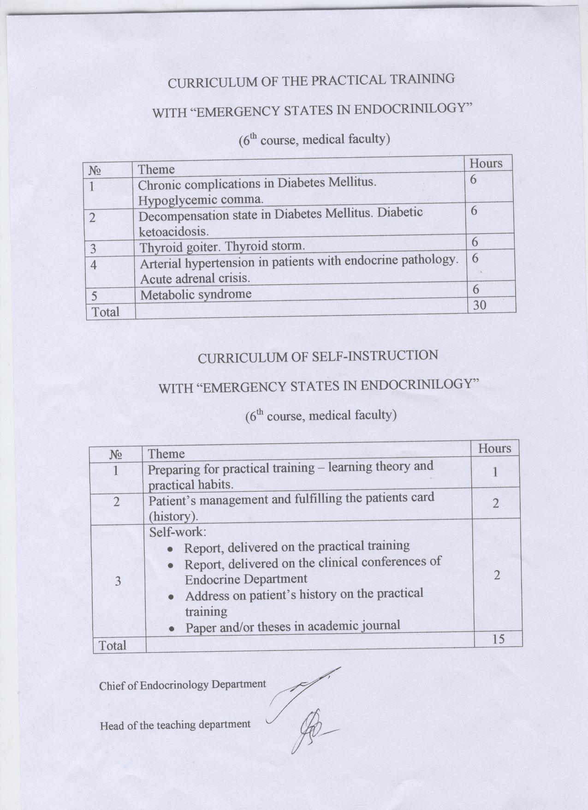

practical lessons schedule
for sixth year students of medical faculty
Practical work - 18 hours
Independent work – 36 hours
2012-2013

№ | Theme of the lesson | Practice | Student’s independent work
1 | Viral hepatitides. Epidemiological situation in different countries. Early diagnosis  of viral hepatitides, diagnostic value of different laboratory tests. Differential  diagnosis of viral hepatitides with other infectious and noninfectious liver diseases  with jaundice (leptospirosis, malaria, sepsis, yersiniosis, infectious mononucleosis, diseases caused by parasites, toxic hepatitides, hemolytic and cholestatic jaundice).  Differential diagnosis of jaundice in pregnant women. Management of patients with acute and chronic viral hepatitides. Antiviral agents for treatment of viral hepatitides, side  effects and adverse reactions. Peculiarities of fulminant forms of viral hepatitides,  mode of treatment of liver encephalopathy. Prevention of viral hepatitides.  HIV infection: etiology, immunopathogenesis, epidemiology, groups of risk.  Stages of disease. Clinical manifestations. Symptoms and signs of AIDS-associated  infections. Opportunistic infections and neoplasms. Diagnosis of HIV infection.  Management of the HIV- infected patients. Pretest counseling. Prevention of HIV  infection. Postexposure prophylaxis. | 6 | 4
2 | Diagnosis and treatment of infections of central nervous system.  Meningococcal infection. Meningitides of different etiology. Laboratory diagnosis  and diagnostic value of different laboratory tests. Viral encephalitides. Differential  diagnosis of meningitides and encephalitides of different etiology. Poliomyelitis.  Enteroviral infection. Emergency in infections of nervous system (brain edema, toxic shock syndrome). Intensive care. Prevention of infections of central nervous system. | 6 | 4
3 | Infections of respiratory system. Diphtheria in adults and its complications.  Diseases accompanied by croup. Influenza and other infections of respiratory  system, differential diagnosis. Peculiarities of epidemic and pandemic influenza.  Emergency in infections of respiratory system (acute respiratory failure, ARDS).  Intensive care. Prevention of infections of respiratory system. | 6 | 4

STRUCTURE OF THE EDUCATIONAL DISCIPLINE FOR MODULES AND
SUBMODULES.
Module 5 «Pediatrics»
Submodule 1. Differential diagnosis of the most common respiratory diseases in children.
Emergency aid for basic emergency conditions.
Submodule2. Differential diagnosis of the most common diseases of the circulatory system in
children. Emergency aid for basic emergency conditions.
Submodule 3. Differential diagnosis of the most common digestive tract diseases in children.
Emergency aid for basic emergency conditions.
Submodule 4. Differential diagnosis of the most common diseases of the urinary system in
children. Emergency aid for basic emergency conditions.
Submodule 5. Clinical supervision for healthy and sick children in a polyclinic. Emergency aid for
basic emergency conditions.
A structured training plan from discipline "Pediatrics, Childhood Infections"for students of
the medical faculty specializing in "Medicine"
Structure of the
educational discipline
Quantity of hours, of which:
Education
al year
Type of control
Total
hours/
credits
Classroom Selfeducatio
Lecture Practical n
Total:
225/7,5 190 65 VI
Module 1.
Pediatrics
Submodules 5
165/5,5 130 35
Current and final
module
(standardized)
Note: 1 credit ECTS – 30 hours; classroom hours – 57,8%; СРС – 42,2%.
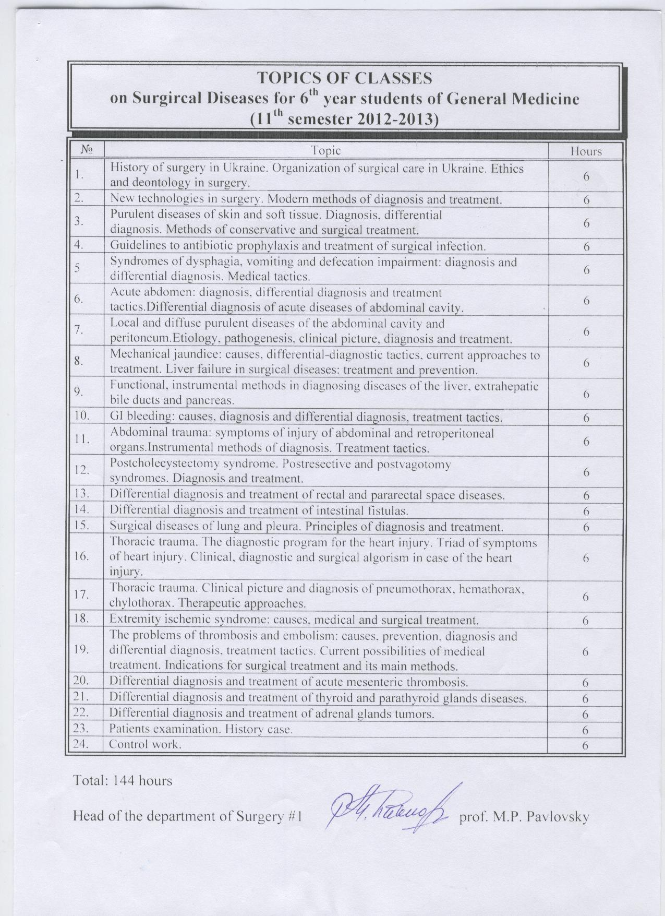
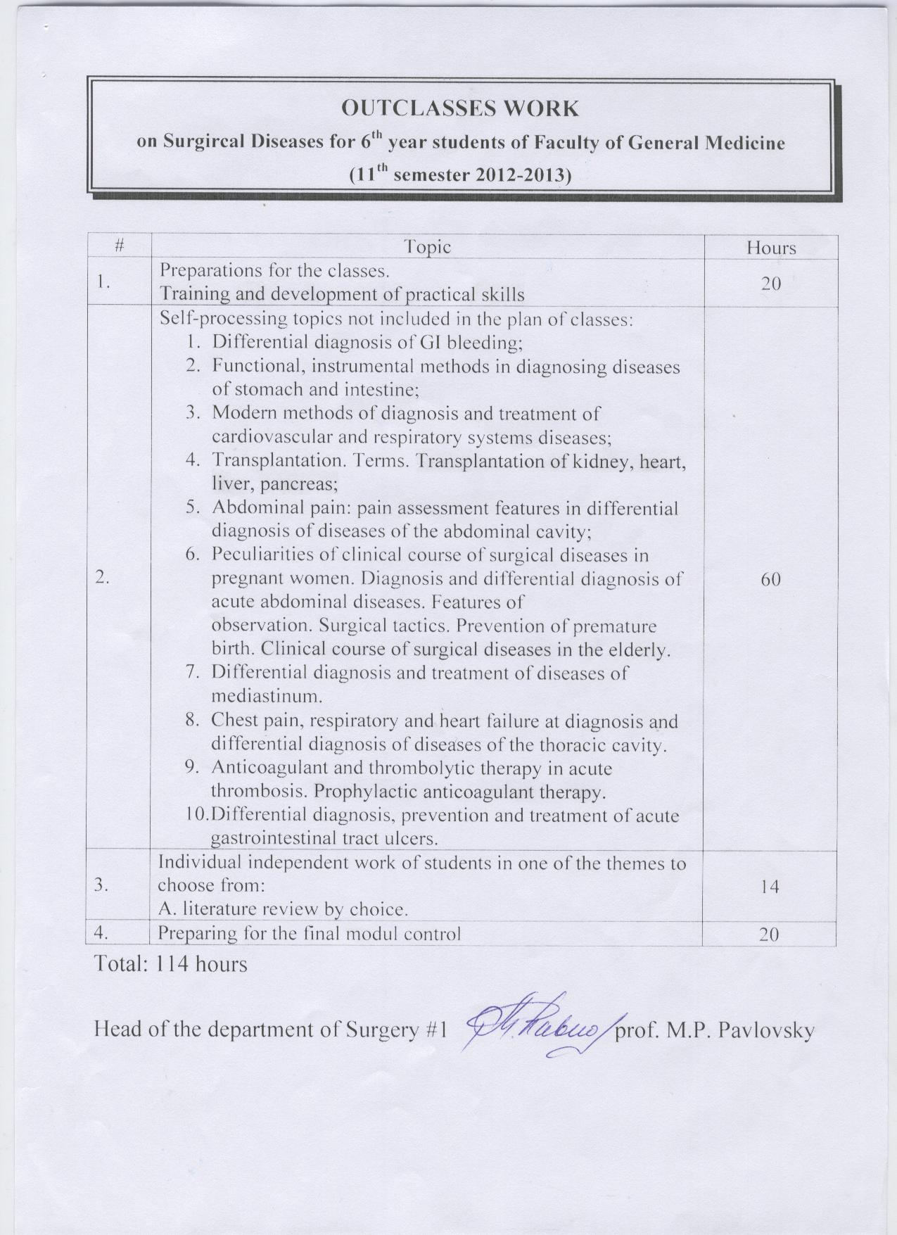
Thematic plan of practical classes in oncology for VIth course foreign students
2012/2013
№ Theme of practical class Hours
1.
Thyroid cancer 6
3. Hodkin`s disease 6
4. Bone and soft tissue tumors 6
Total 18
Thematic plan of outclasses work Hours
1 Combined methods of treatment 4
2 Tumors of head and neck 4
3 Bone marrow disorders 4
Total 12

Topics plan for out of class assignment on pediatric surgery for 6-th year medical students.

# | Topics | Hours
1 | Congenital lung cysts. Lung hypoplasia. Congenital lobar emphysema. | 3
2 | Chronic constipation syndrome. Hirschsprung disease. | 3
3 | Congenital urological abnormalities in children. | 3
5 | All together | 9

Topics plan for practical classes on pediatric surgery for 6-th year medical students.

# | Topics | Hours
1 | Congenital malformation of gastrointestinal tract (esophageal atresia, diaphragmatic hernia, congenital bowel obstruction). | 6
2 | Congenital malformations of bones and joints. | 6
3 | Congenital malformations of front abdominal wall. Congenital anorectal malformations. | 6
4 | All together | 18

THE PLAN
of practical lessons of hygiene for the VI years students general medicine faculty in 2012-2013 a.y.
№ | Themes of seminars | hrs | 5 ін. | 6 ін.
1 | Methodological, methodical principles of studying and risk assessment of environmental  factors influence on population health. Preventive toxicology. Principles and methods of  hygienic normalization of harmful chemical substances in different environmental objects | 6 | 03.09 | 15.11
2 | Hygiene of water and water-supply, sanitary protection of water objects and soil, cleaning of  settlements. Hygienical aspects of planning and exploitation, prophylaxis of in-hospital  nfection, ultraviolet irradiation and radiation safety in treating-and-prophylactic establishments | 6 | 04.09 | 16.11
3 | Nutrition in preventive medicine. A treatment-and-preventive and ecological-and-protective  nutrition. The Sanitary-and-hygienic control over a clinical (dietary) nutrition | 6 | 05.09 | 19.11
4 | Legislative bases of the medical and prophylactic providing of workers. Hygienical estimation  of process of labor and factors of industrial environment. Hygienical value of contamination  of atmospheric air and physical factors in settlements. Hygiene of planning of settlements | 6 | 06.09 | 20.11
5 | The complex estimation of individual and population health and physical development of  children. Hygienic requirements to planning, improvement of children’s institutions and the  organization of training and educational process | 6 | 07.09 | 21.11
6 | The organization of sanitary inspection on temporary placing feeding and water-supplying  of the rescue units and population in emergency situations. The forming of radiation load  and hygienic aspects of residence of population on territories which were exposed to the  radioactive contamination | 6 | 10.09 | 22.11
7 | Modul | 4 | 11.09 | 23.11
Total 40 hrs.

THE PLAN
of independent work hygiene for the VI years students general medicine faculty in 2012-2013 a.y.

№ | Themes of independent work
1 | Preparation to practical lessons | 10
2 | Hygienical estimation of influence of natural and anthropogenic components of biosphere on a health man and population. Scientific bases of medical biorhythmology and chronohygiene | 1
3 | A hygienical estimation of terms of stay of patients in medical establishments. Features of antiradiation protection of personnel and patients in roentgenologic and radiological departments | 2
4 | Food poisonings as hygienical problem. Method of investigation of cases of the food poisonings | 1
5 | A hygiene of labor of medical workers in treatment-and-preventive establishments | 1
6 | Hygienical principles of rational organization of physical education and labour studies of children and teenagers. Scientific bases of conducting of medical-professional consultation | 1
7 | Organization and conducting of sanitary supervision after the terms of labour of liquidators of consequences of extraordinary situations | 1
8 | Preparation to module control | 3
Total 28 hrs.

THEMATIC PLAN
for educational discipline “Social medicine, economics and organization of health care” for the VIth year students of medical faculty
after medical speciality 7.110101 “General medicine” in 2012-2013 academic year
Module № 3. Organization of medical help for population. Economy of health care № |  | The theme of practical class |  | Hours amount
1. |  | Management of staff potential at primary and tertiary level of medical securing of population according to directive of MPH №33 from 23.02.2000 “On staff standards and common staff of establishments of public health services” |  | 2
The market of health care and methods of its investigation |  |  | 4
2. |  | Methodology of filling and analysis of main accounting documentation that regulates birth process according to current legislation, normative, legal and instructive documents by doctor |  | 4
Finance in the health care |  |  | 2
3. |  | Methodology of filling and analysis of main accounting documentation that regulates death process according to current legislation, normative, legal and instructive documents by doctor |  | 4
Organization of medical insurance as mechanism of financing of the health care system |  |  | 2
4. |  | Accounting and statistical documentation in the doctor’s activity in the policlinic |  | 2
Payments for providers of medical service |  |  | 4
5. |  | Accounting and statistical documentation in the doctor’s activity in the hospital |  | 2
Methodology of price formation and regulation prices in the health care system |  |  | 4
6. |  | Technique of temporary disability examination due to disease, trauma, accident, pregnancy and future delivery, nursing care according to current legislation and normative documents at outpatient and hospital establishments |  | 4
Business activity in the health care |  |  | 2
7. |  | Role and place of risk factors, preventive and dispensary technologies in strengthening and preserving population health according to state program “Health – 2020: Ukrainian choice” |  | 2
Marketing in the health care system |  |  | 4
8. |  | Methodological recommendations for passing practically-oriented exam on the discipline “Social medicine, economics and organization of health care” according to medical speciality 7.110101 “General medicine” |  | 2
Test-control of knowledge from self-testing extracurricular work for informative module “Economics of health care” |  |  | 4
9. | Final module  control №3 |  | Part I. Passing test control |  | 1
Part II. Writing determination of situational tasks №1 and №2 |  |  | 1
Total |  |  | 50

