**THEMATIC PLAN**

# FOR THE PRACTICAL COURSE IN THE DISCIPLINE

**“EMERGENCY MEDICINE IN EXTREME CONDITIONS”**

**for the 4th year student of the stomatological faculty,**

**academic year 2012-2013**

|  |  |  |
| --- | --- | --- |
| № | Topic | Hours |
| 1. | Radiation damage in peacetime and wartime | 2 |
| 2. | Poisoning in peacetime and wartime | 2 |
| 3. | Diseases of internal organs in patients with polytrauma | 2 |
| 4. | General questions of intensive care of emergencies in extreme conditions | 2 |
| Total 8 hours | | |

**THEMATIC PLAN**

**FOR LECTURES COURSE IN THE DISCIPLINE**

**“EMERGENCY MEDICINE IN EXTREME CONDITIONS”**

**for the 4th year student of the stomatological faculty,**

**academic year 2012-2013**

|  |  |  |  |  |
| --- | --- | --- | --- | --- |
| № | Topic | Hours | Date | Tutor |
| 1. | Organization of qualified and specialized therapy of survivors in extreme conditions | 2 | 21.09 | Sаtsuk S.О. |

**THEMATIC PLAN**

**FOR SELF-STUDY IN THE DISCIPLINE**

**“EMERGENCY MEDICINE IN EXTREME CONDITIONS”**

**for the 4th year student of the stomatological faculty,**

**academic year 2012-2013**

|  |  |  |
| --- | --- | --- |
| № | Topic | Hours |
| 1. | Syncope. Collapse. Emergency aid during medical evacuation | 2 |
| 2. | Drowning, emergency aid | 2 |
| 3. | Comas, classification, differential diagnosis, emergency aid | 2 |
| 4. | Shocks, classification, differential diagnosis, emergency aid | 2 |
| **Total 8 hours** | | |

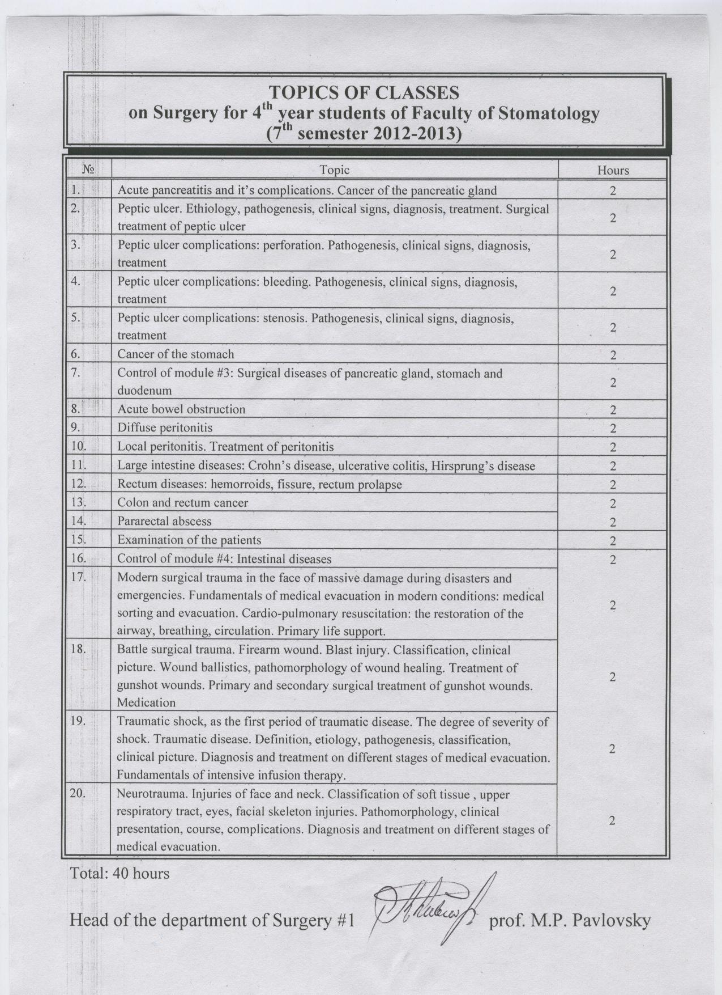

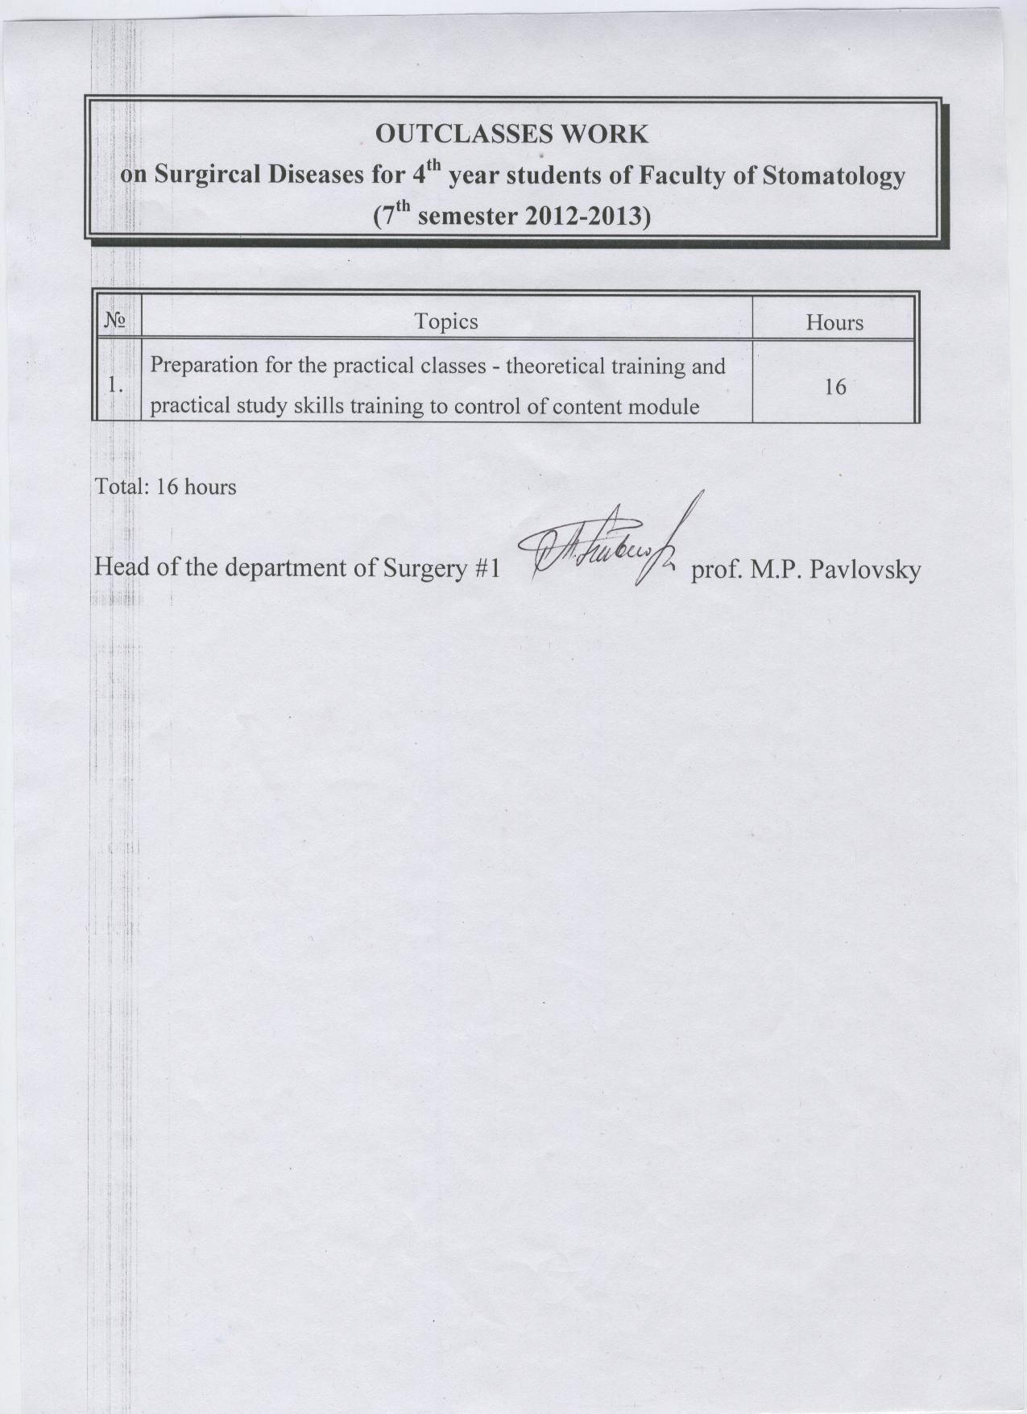

**THE PLAN of lectures on Psychiatry and Narcology, for FOURTH-YEAR students /English-speaking group/, stomatology faculty, 2012-2013.**

|  |  |  |  |  |
| --- | --- | --- | --- | --- |
| **№** | **Topic:** | **Hrs:** | **Date:** | |
| **1** | Subject, tasks of psychiatry and narcology, main stages of its development. Conception of psychic disorders and its expending. Classification of psychic disorders. Pathology of perception, cognition, memory and attention. Pathology of consciousness. Demonstration of patients. | **2** | **30.01.12** | |
| **2** | Schizophrenia. Peculiarities of its clinics, progression, therapy. Demonstration of patients. Problem of alcoholism. Aged peculiarities of alcoholism. Demonstration of patients. Problem of psychohygiene. Neuroses, reactive psychoses. Psychopathics. Ecological psychiatry. Demonstration of patients. Psychotherapy. Demonstration of patients. | **2** | **28.02.12** | |
|  | **ALL:** | **4** |  |

**THE PLAN of practice on Psychiatry and Narcology, for FOURTH-YEAR students /English-speaking group/, stomatology faculty, 2012-2013.**

|  |  |  |
| --- | --- | --- |
| **№** | Topic: | Hrs. |
| 1 | Organization of psychiatric and narcologic help in Ukraine. Subject, tasks of psychiatry and narcology. Methods of the examination of mental patients. Round of the clinic and other departments of the LSDCPH /Lviv State District Clinical Psychiatric Hospital. 16.01. | 2 |
| 2 | Pathology of perception, cognition, memory and attention. Analysis of the patient's anamnesis. 23.01. | 2 |
| 3 | Pathology of emotional and volitional activity. Analysis of the patient's anamnesis. 30.01. | 2 |
| 4 | Pathology of thought and intellect. Analysis of the patient's anamnesis. 06.02. | 2 |
| 5 | Pathology of consciousness and self-consciousness, Syndromes of impaired consciousness. Analysis of the patient's anamnesis. 13.02. | 2 |
| 6 | Main, psychopathologic syndromes. Study of the SEG /electro- encephalography/, laboratory and psychotherapuetic centre of the Mental Hospital. 20.02. | 2 |
| 7 | Schizophrenia. Clinics, progression, therapy. Study of the rehabilitational centre of the Mental Hospital. Analysis of the patient's anamnesis. 27.02. | 2 |
| 8 | Manic-depressive psychoses. Cyclothymia. Visit to the clinical department and discussion. Ambulatories analysis of the patient's anamnesis. Supervision. 05.03. | 2 |
| 9 | Alcoholism, aged peculiarities. Clinics, progression, therapy. Psychoses of alcoholism. Study of the narcologic and resuscitation departments of the Mental Hospital. Analysis of the patient's anamnesis.  Harcomania, taozomania. Nicotinism. Visit to the narcolo-gical department. Analysis of the patient's anamnesis. 12.03. | 2 |
| 10 | Epilepsy and its syndromes. Psychic disorders in acute and following periods of cramisl brain trauma. Clinics, treatment, esrpertise and cabala of working. Visit to the office of the specialist on epilepsy. Analysis of the patient's anamnesis. 19.03. | 2 |
| 11 | Psychic disorders in cases of somatic, endocrinic, infec­tious disorders, diseases. AIDS. Progressive paralysis and brain syphylis. Intoxitional psychoses. Analysis of the patient's anamnesis. 26.03. | 2 |
| 12 | Psychoses of the reverse development, involutional and senile. Psychic disorers in a case of brain vessel disease. Clinics, progression, treatment. Vessel dementia. Alzheimer and Pick diseases. Visit to a herontologic department of the LSDCPH. Analysis of the patient's anamnesis. 02.04. | 2 |
| 13 | Neuroses and reactive states. Visit to the neurotic department of the LSDCPH. 9.04. | 2 |
| 14 | Psychopathy. Acquaintance with modern methods of psycho­therapy. Visit to the teenage department of the LSDCPH. Analysis of the patient's anamnesis. 16.04. | 2 |
| 15 | Oligophrenia. Visit to the children department of the LSDCPHo Analysis of the patient's anamnesis. Problem of the expertise. Defence of a case history. 23.04. | 2 |
|  | All: | 30 |

**LECTURES**

**on Pediatrics for students year 4**

**2012/2013 Academic Year**

**Module I. The most prevalent somatic diseases in children**

**№**

**Subject hrs**

1. Rachitis. Hypervitaminosis D 2

2. Protein-caloric malnutrition 2

3. Acute respiratory infections of upper airways in children 2

4. Acute bronchitis in children 2

5. Pneumonia in children 2

6. Bronchial asthma in children 2

7. Drug allergy. Emergency care. 2

8. The most prevalent congenital heart disease 2

9. Connective tissue disease 2

10. Changes in cardiac rhythm and conductance in children 2

11. Functional diseases of gastrointestinal tract 2

12. Organic disease of the stomach and duodenum 2

13. Urinary tract infections in children 2

14. Glomerulonephritis in children. Metabolic disease and kidney 2

15. Acute and chronic renal failure 2

**Total 30**

Lectures are timed at 13:45 to 15:20.

**WORKSHOPS**

**on Pediatrics for students year 4**

**Module I. The most prevalent somatic diseases in children**

№ Subject hrs

1 Functional gastrointestinal disorders in infants and preschool children 4

2 Rachitis. Hypervitaminosis D 4

3 Protein-caloric malnutrition in children 4

4 Acute respiratory tract infections in children 4

5 Acute bronchitis in children 4

6 Pneumonia in children 4

7 Atopic dermatitis and urticaria in children 4

8 Allergic rhinitis in children. Atopic march 4

9 Bronchial asthma in children 4

10 The most prevalent congenital heart disease in children. 4

11 Inflammatory and non-inflammatory diseases of the heart in children. 4

12 Acute rheumatic fever in children. 4

13 Juvenile rheumatoid arthritis and reactive arthritis in children 4

14 Functional diseases of esophagus and stomach in children. 4

15 Organic diseases of esophagus, stomach, and duodenum in children. 4

16 Functional and organic diseases of intestines and bile ducts in children 4

17 Urinary tract infections in children 4

18 Glomerulonephritis in children. 4

19. Acute and chronic renal failure in children 4

20 Medical records 2

Final assessment of module I 2

Total 80

**TIME-TABLE OF PRACTICAL SESSIONS OF OTORHINOLARYNGOLOGY**

**for Stomatological students 4 year**

**2012-2013 year**

|  |  |  |  |
| --- | --- | --- | --- |
|  | **Hours** | **Subject of the practical session** |  |
| 1. | 2 | Endoscopical examination of ENT. | 07.09.2012 |
| 2. | 2 | Clinical anatomy, physiology, methods of investigation of the hearing apparatus. | 14.09.2012 |
| 3. | 2 | Clinical anatomy, physiology, methods of investigation of the vestibular apparatus | 21.09.2012 |
| 4. | 2 | Clinical anatomy, physiology, methods of investigation of the nose and paranasal sinuses, pharynx and larynx | 28.09.2012 |
| 5. | 2 | External otitis (local, diffuse). Impacted cerumen. Acute purulent otitis media. Mastoiditis | 5.10.2012 |
| 6. | 2 | Chronic purulent otitis media, labirintits | 12.10.2012 |
| 7 |  | Otogenic intracranial complications | 19.10.2012 |
| 8 | 2 | Chronic nonpurulent otitis media. Sensorineural hearing loss. Meniere’s disease. | 26.10.2012 |
| 9. | 2 | Acute and chronic rhinitis, nasal septum deviation, furuncle of the nose | 2.11.2012 |
| 10 | 2 | Acute and chronic sinusitis. Polyps of the nose. Odontogenic maxillary sinusitis | 9.11.2012 |
| 11. |  | Rhinological intracranial and orbital complications | 16.11.2012 |
| 12. | 2 | Acute and chronic pharyngytis, pharyngomycosis, acute tonsillitis, diphtheria, perytonsilar and retropharyngeal abscess. | 23.11.2012 |
| 13. | 2 | Chronic tonsillitis. Hypetrophy of the tonsils and adenoids | 30.11.2012 |
| 14. | 2 | Acute laryngitis. Laryngeal stenosis Intubation and tracheostomia. | 7.12.2012 |
| 15. | 2 | Acute laryngotracheitis in children, chronic laryngitis, laryngeal diphtheria | 14.12.2012 |
| 16. | 2 | ENT tumors. Infectional granulomas. | 21.12.2012 |
| 17 | 2 | Trauma, foreign bodies and hemorrhages of ENT, urgent care. Checkup. | 28.12.2012 |
| 18 | 2 | Checkup. | 17.01.2012 |

**TIME-TABLE**

**OF LECTURES OF OTORHINOLARYNGOLOGY**

**for Stomatological students 4 year,**

**2012-2013 year**

|  |  |  |  |
| --- | --- | --- | --- |
| N | Hours | Subject of the lecture | Date |
| 1. | 2 | Acute purulent otitis media. Mastoiditis. | 04.09.12 |
| 2. | 2 | Chronic purulent and nonpurulent otitis media | 18.09.12 |
| 3. | 2 | Acute and chronic rhinosinusitis. Allergic rhinitis. | 2.10.12 |
| 4. | 2 | Acute and chronical tonsillitis. Classification. Physiologyof lymfadenoid pharyngeal ring | 16.10.12 |
| 5. | 2 | Laryngeal diseases. Laryngeal Stenosis. First aid. | 30.10.12 |

**TIME-TABLE**

**OF INDEPENDENT WORK OF OTORHINOLARYNGOLOGY**

**for Stomatological students 4 year,**

**2012-2013 year**

|  |  |  |
| --- | --- | --- |
| **№** | **Hours** | **Subject of the practical session** |
| 1. | 2 | Additional methods of examination of ENT organs, CT, MRI |
| 2. | 2 | Reconstructive surgery of the nose and the face |
| 3. | 2 | Collateral action of a medicine in otolaryngology |
| 4. | 2 | Stenosis of respiratory tract. First aid |
| 5. | 2 | AIDS in otolaryngology |
| 6. | 2 | Congenital disorders of ENT organs |
| 7. | 2 | Professional frustration of ENT organs |
| 8. | 2 | Costen syndrome |
| 9. | 2 | Physiotherapy in otolaryngology |
| 10. | 2 | Allergic diseases in otolaryngology |
| 11. | 2 | Lviv otolaryngological school |
|  | 22 | Total |

**Lviv National Medical University named after Danylo Galitsky**

**Department of Neurology&Neurosurgery**

**For 4th year Dentistry Faculty Students in 2012-2013**

**Theme of Lectures**. (4 hours)

1. Brain injury. Spine and spinal cord injury. CNS tumors (2 hours)
2. Cerebral vascular diseases. Spine degeneration. Facial pain. Trigeminal neuralgia (2 hours).

**Practical Sessions**. (16 hours)

1. Brain injury: classification, periods. Brain concussion. Brain contusion of mild and moderate degree. Severe brain contusion. Diffuse axonal injury. (2 hours).
2. Intracranial traumatic mass lesions: hematomas, compound skull fractures. Brain herniation. Skull base fractures. Cranial-facial injuries. (2 hours).
3. Injury to the spine and spinal cord: classification, types of vertebral fractures. (2 hours).
4. Neurooncology. Brain tumors. Hydrocephalus. Spinal tumors. Histological types, methods of treatment. (2 hours).
5. Vascular diseases of CNS. Hemorrhagic stroke. Subarachnoid hemorrhage. Arterial aneurysms and arterial-venous malformations. (2 hours).
6. Vascular diseases of CNS. Ischemic stroke. Spinal cord vascular disease.
7. Degenerative diseases of the spine, cervical, lumbar discs. Trigeminal neuralgia.Glosso-pharyngeal neuralgia, facial pain. (2 hours).
8. Module control. (2 hours).

**Self-education work** (10 hours)

1. History of neurosurgery. Diagnostic methods in neurosurgery: invasive, non-invasive, diagnostic surgery. (3 hours).
2. Odontogenic brain and spinal cord abscesses. Purulent epiduritis. (2 hours).
3. Congenital CNS diseases. Anterior cranial hernias (2 hours).
4. Trauma of peripheral nerves. (3 yours).

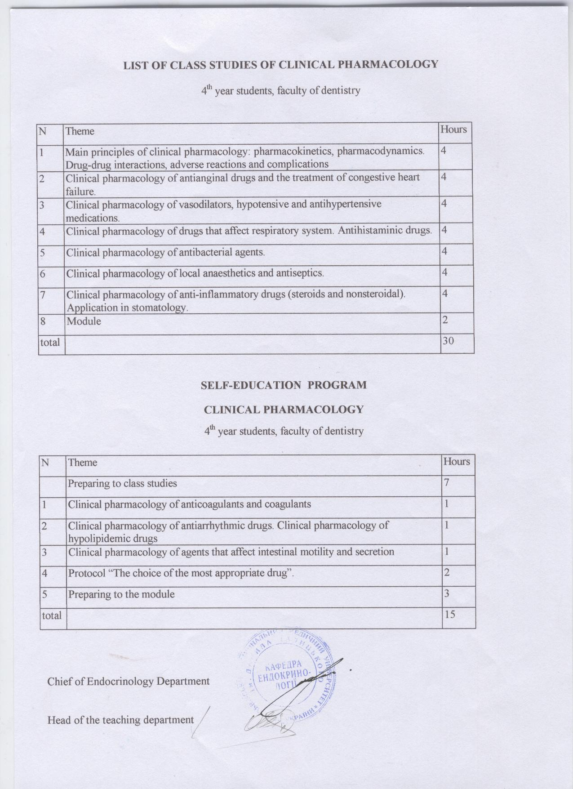

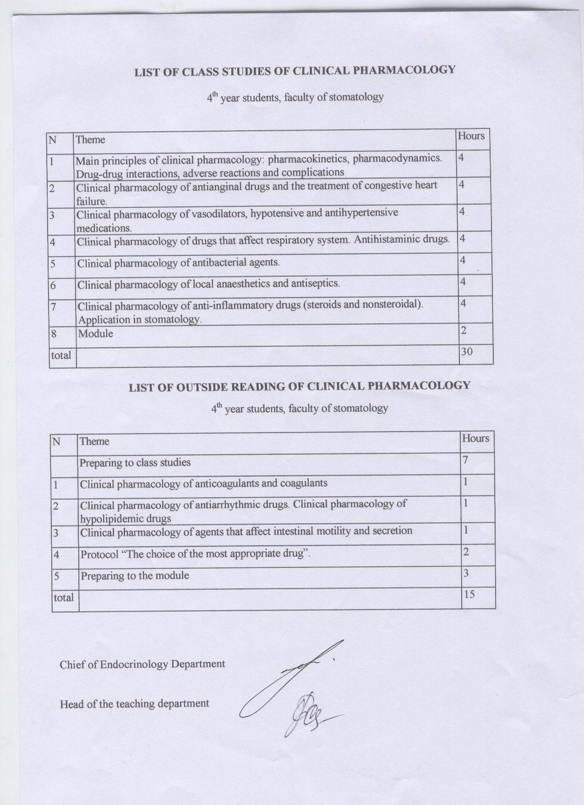

**Plans of lectures, practical lessons, out of class work and individual work in discipline „Periodontology” for 4-rd year**

**English-medium students (7-rd term)**

**Credit-Module System**

**LECTURES (4 hours)**

|  |  |  |  |
| --- | --- | --- | --- |
| **№** | **Topic of the lecture** | **Hours** | **Date** |
| 1. | Periodontology as a part of therapeutic dentistry. Anatomical-physiological peculiarities of periodontal tissues. Methods of examination of patients with periodontal pathology. Diseases of the periodontium. Classification. | 2 |  |
| 2. | Etiology, pathogenesis, clinical peculiarities, diagnosis, differential diagnosis and prophylaxis of inflammatory periodontal diseases (papilitis, gingivitis, localized periodontitis). | 2 |  |

**Practical lessons**

**Module 2: „Diseases of the periodontium. Etiology, pathogenesis. Classification, clinical features, diagnosis, treatment, prophylaxis”– 6 credits (180 hours): lectures – 10 hours, practical lessons – 110 hours, self education – 60 hours.**

Module № 5.

Diseases of the periodontium. Systematisation of periodontal diseases. Peculiarities of clinical examination in periodontal pathology

|  |  |  |  |
| --- | --- | --- | --- |
| **№** | **Topic** | **Pract.**  **lessons** | **Individual work** |
| 1. | Determination of the initial level of knowledge. Prevention of accidents in clinic of therapeutic dentistry. | 2 | 1 |
| 2. | Clinical and morpho-functional peculiarities of periodontal tissues. Dento-gingival junction. Age changes of the periodontium. Clinical meaning (the term „periodontium”. Anatomy, histology, physiology of the periodontium). Protective mechanisms. | 2 | 1 |
| 3. | Diseases of the periodontal tissues. Terminology. Classification of periodontal diseases. Positive and negative sides of the classifications. | 2 | 1 |
| 4. | Peculiarities of clinical examination of patients with periodontal pathology. The most important clinical methods of examination. | 2 | 1 |
| 5. | Additional methods in the diagnosis of periodontal diseases. Periodontal indices. | 2 | 1 |
| 6. | X-ray diagnosis in patients with periodontal pathology. | 2 | 1 |
| 7. | Laboratory, functional methods of diagnosis in patient with periodontal pathology. | 2 | 1 |
| 8. | The mechanism of development of supra- and subgingival dental calculus, its influence on the development of periodontal pathology, ways of debridment procedures. | 2 | 1 |
| 9. | Mistakes and complications in diagnosis of patients with periodontal pathology. Concluding control of knowledge. | 2 | 1 |

Module № 6.

Inflammatory periodontal diseases (papilitis, gingivitis, localized periodontitis)

|  |  |  |  |
| --- | --- | --- | --- |
| **№** | **Topic** | **Pract.**  **lessons** | **Individual work** |
| 10. | Etiology and pathogenesis of inflammatory periodontal diseases. | 2 | 2 |
| 11. | Papilities, gingivitis. Classification. Clinical sings of catarrhal (simple) gingivitis. | 2 | 2 |
| 12. | Treatment of catarrhal gingivitis. | 2 | 2 |
| 13. | Hypertrophic gingivitis. Clinic, diagnosis. | 2 | 2 |
| 14. | Treatment of hypertrophical gingivitis. | 2 | 2 |
| 15. | Ulcerative gingivitis. Clinic, diagnosis. | 2 | 2 |
| 16. | Treatment of ulcerative gingivitis. | 2 | 2 |
| 17. | Atrophic and desquamate gingivitis. Clinical sings and treatment. | 2 | 2 |
| 18. | Differential diagnosis of gingivitis. The role of gingivitis in the development of periodontitis. Gingivitis prevention. | 2 | 2 |
| 19. | Localized periodontitis. Clinic, diagnosis. | 2 | 2 |
| 20. | Treatment and prophylactic of localized periodontitis. | 2 | 1 |

**OUT OF CLASS WORK (30 hours)**

|  |  |  |
| --- | --- | --- |
| **№** | **Topic** | **Hours** |
| 1. | Preparation for practical lessons: theoretical and practical training. | 20 |
| 2. | Working-out of practical topics not included in practical classes:   * The contribution of scientists of Ukraine and foreign scientists in the investigation of etiology and pathogenesis of periodontal diseases. * Estimation criteria of the condition of periodontal tissues. * Writing of dental documentation, quantative and qualitative indices in the work of dentist. * Analysis of the results of the laboratory tests (cytological, histological, bacterial). * Conduction and estimation of the additional methods of investigations. | 2  2  2  2  2 |

**INDIVIDUAL WORK (2 points)**

|  |  |  |
| --- | --- | --- |
| **№** | **Topic** | **Points** |
| 1. | Estimation of periodontal indices. | 1 |
| 2. | Clinical examination of patient with periodontal pathology. Medical history report, conduction of treatment plan. | 1 |

**LECTURE lessons schedule of oral surgery  
for English-medium students of the 4th year education on dental faculty   
in autumn semester of 2012-2013 academic years**

|  |  |  |  |  |
| --- | --- | --- | --- | --- |
| № | Topic | hours | Lecture | Date |
| 1 | 2 | 3 | 4 |  |
| 1 | Classification of tumors of Maxillofacial Area, etiology, pathogenesis, peculiarities of growth and determination, modern diagnostics methods. Cysts of jaws (оdontogenic and non-odontogenic, epithelial and non-epithelial). Odontogenic cysts of jaws ( radicular, follicular, gingival , follicular, eruption ): etiology, pathogenesis, classification, histological structure, clinical signs, diagnostics, surgical treatment, prevention of complications | 2 | Professor Yan E. Vares | 21.09.12 |
| 2 | Bening odontogenic tumors of the jaws ( ameloblastoma, odontomas, cementoma, epulis ) | : classification, histological structure|building|, clinical signs, differentiation, principles and methods of surgical treatment, prevention of complications|complication|. Bening non-odontogenic| tumours|swelling| of the jaws (osteoblastoma|, osteoma|, osteoid-osteoma|, chondroma|, hemangioma|, fibroma): etiology, pathogenesis, classification, histological structure, clinical signs, diagnostics, surgical treatment, prevention of complications. | 2 | Professor Yan E. Vares | 19.10.12 |
| 3 | Bening tumours|swelling| of soft tissues of Maxillofacial area and neck (papilloma|, fibroma, lipoma|, hemangioma|, atheroma|, neurofibromatosis|): etiology, pathogenesis, classification, histological structure, clinical signs, diagnostics, surgical treatment, prevention of complications.  Tumor-like lesions new of soft|mild| tissues of Maxillofacial area (dermoid| and epidermoid cysts, midline, lateral or branchial cysts of neck and fistules|): etiology, pathogenesis, classification, histological structure, clinical signs, diagnostics, surgical treatment, prevention of complications. | 2 | Professor Yan E. Vares | 16.11.12 |
| 4 | Organization of surgical treatment in patients with traumatic injures of Maxillofacial area| . Basic principles of surgical treatment organization in patients with gunshot injuries of the bones of the facial skeleton in extreme conditions. Injures of lower|bottom| jaw: anatomic location, classification, clinical examination, diagnostic methods. Principles of lower fractures treatment. Prevention of complications|complication| | 2 | Professor Yan E. Vares | 30.11.12 |
| Total: | | 8 |  |  |



**THEMATIC PLAN**

**Lectures (1-4), Practical Lessons (1-16),**

**Materials (1-5) for self-conducted elaboration (Independent work)**

**on Prosthetic Dentistry, 4th Year, 7th Semester**

|  |  |  |
| --- | --- | --- |
| № | Themes contents | Acad. hours |
|  | Clinical evaluation and treatment planning for the edentulous patients. Technique of functional impressions. Selective pressure impression techniques | 2 |
|  | Registration of intermaxillary relations. Articulators and occlusion in complete denture fabrication. Mechanisms of complete denture retention. Pre-definitive treatment and rehabilitation prostheses | 2 |
|  | ***In total*** | 4 |
| **Module 3. Complete removable prosthodontics** | | |
| Contextual module 1.Clinical examination of edentulous patients. Impression techniques. Biomechanics of mandibular movements. | | |
| 1. | Control of the initial knowledge level. Clinical evaluation and treatment planning for the edentulous patients. | 3 |
| 2. | Anatomical upper and lower impressions taking in edentulous patients for the individual trays fabrication. | 3 |
| 3. | Upper and lower individual trays fabrication. | 3 |
| 4. | Individual adjusting of custom-made rigid trays. | 3 |
| 5. | Upper and lower functional impressions taking. | 3 |
| 6. | Centric relation/occlusion registration in Betelman’s I-IV clinical situations. | 3 |
| 7. | Biomechanics of mandibular movements. Factors of occlusion. | 3 |
| 8. | Theory of articulation: basic principles and clinical application. | 3 |
| 9. | Methods of articulators use in complete removable prosthodontics. | 3 |
| Contextual module 2. Laboratoty stages in complete removable dentures fabrication. Material- and construction-related local and systemic reactions in edentulous patients. | | |
| 10. | Anatomical arrangement of acrylic teeth to customize tooth contacts size, shape and colour (by glass, spherical plane) | 3 |
| 11. | Try-in appointment: verifying teeth selection, basis placement, peripheral seal, jaws relations. Communication between dentist and technician in possible faults correction | 3 |
| 12. | Laboratoty stages (materials, techniques) in of complete removable dentures fabrication. | 3 |
| 13. | Fitting and insertion visit: adjustments, recommendations, post-insertion appointments | 3 |
| 14. | Complete denture relines, repairs and rebases processing. Hard and resilient materials, soft denture liners in complete denture fabrication. | 3 |
| 15. | Complete removable dentures material- and construction-related influence on oral tissues. Preventive measures of possible complications. | 3 |
| 16. | Contextual module control | 3 |
|  | ***In total*** | 48 |
| 1. | Biomechanical peculiarities of mandibular movements in individuals of different age groups. | 20 |
| 2. | Theories of the maxillofacial articulation and their application in clinical practice. | 4 |
| 3. | Contextual module control | 4 |
|  | ***In total*** | 28 |
|  | ***On aggregate in the Semester*** | **80** |

**THE PRACTICAL LESSONS SCHEDULE**

**on Pediatric Therapeutic Dentistry**

( for 4th year students of dental faculty, 7th term 2012-2013 years)

***(Hours – 40)***

|  |  |  |
| --- | --- | --- |
| N | Topic of the lesson | Hour |
| 1 | Clinical and rentgenological aspects of anatomical structures of primary and permanent teeth depending on the stages of their development. Influence of teeth structure on the development and course of diseases of dental hard tissues, pulp and periapical tissues in children. | 2 |
| 2 | Dental caries of primary teeth. Etiology and pathogenesis. Peculiarities of clinical manifestations and course. Diagnostics, differential diagnostics. | 2 |
| 3 | Caries treatment of primary teeth in children. Peculiarities of preparation of carious cavities of primary teeth . Choice of filling materials. Silver impregnation as a method of treatment of deciduous teeth | 2 |
| 4 | Dental caries of permanent teeth. Peculiarities of clinical manifestations and course. Diagnostics, differential diagnostics. | 2 |
| 5 | Caries treatment of permanent teeth in children. Peculiarities of preparation and filling of carious cavities at different forms of dental caries. Choice of filling materials. General treatment of caries: planning, methods. | 2 |
| 6 | Mistakes and complications during treatment of caries in children of different ages. Their prevention and elimination | 2 |
| 7 | Non-carious lesions of the hard dental tissues in children. Enamel hypoplasia: etiology, clinical manifestations , diagnostics, differential diagnostics, treatment, prevention | 2 |
| 8 | Fluorosis: clinical appearance, diagnostics, differential diagnostics, treatment, prevention. | 2 |
| 9 | Hereditary disturbances of development of dental hard tissues. Amelogenesis imperfecta, dentinogenesis imperfecta, dysplasia Stentona-Kapdepona. Clinical manifestations, diagnostics, tactics of pediatric dentist. | 2 |
| 10 | Dental caries and non-caries lesions in children | 2 |
| 11 | Pulpitis of primary teeth in children. Peculiarities of clinical manifestations in children of different age. Diagnostics, differential diagnostics. | 2 |
| 12 | Pulpitis of permanent teeth in children. Peculiarities of clinical manifestations in children of different age. Diagnostics, differential diagnostics. | 2 |
| 13 | Methods of treatment of pulpitis in primary and permanent teeth in children depending on the form of pulpitis and stage of tooth development. | 2 |
| 14 | Treatment of pulpitis of primary teeth in children. Devital amputation and extirpation of pulp . Indications, technique, monitor the effectiveness, prognosis. | 2 |
| 15 | Treatment of pulpitis of permanent teeth in children. Conservative treatment method. Indications, technique, monitor the effectiveness, prognosis. | 2 |
| 16 | Treatment of pulpitis of permanent teeth in children. Vital amputation and exterpation . Indications, technique, choice of filling materials for root fillings | 2 |
| 17 | Treatment of pulpitis of permanent teeth in children. . Devital methods. Indications, technique, prognosis. | 2 |
| 18 | Mistakes and complications in treatment of pulpitis of primary and permanent teeth in children. Their prevention and elimination. | 2 |
| 19 | Peculiarities of clinical course of pulpitis in children | 2 |
| 20 | Peculiarities of treatment of pulpitis in children | 2 |
| 19 | Summary module control | 2 |
|  | Whole | 40 |

**THE SELF-WORK SCHEDULE**

**on Pediatric Dentistry**

( for 4th year students of dental faculty, 7th term 2012-2013)

|  |  |  |  |
| --- | --- | --- | --- |
| N | Topic of lesson | Hours | Types of control |
| 1. | **Preparing to the practical classes ( theoretical, mastering of practical skils)**  Topics: **1-20** | 20 | Current  On the practical classes |

PRACTICAL LESSONS SCHEDULE

(for the fouth year students of stomatology faculty, 7th term 2012-2013 years)

**Orthodontics**

|  |  |  |
| --- | --- | --- |
| **Thеmatic module № 1. Anomalies of individual teeth.** | | |
| 1 | Anomalies of teeth. | 2 |
| 2 | Anomalies of number, size and eruptions. | 2 |
| 3 | Anomalies of the position of individual teeth. | 2 |
| 4 | Treatment of anomalies of the position of individual teeth. | 2 |
| 5 | Anomalies of the dental arches. | 2 |
| **Themantic module № 1. Anomalies of occlusion.** | | |
| 6 | Sagittal anomalies of occlusion. Posterior occlusion. Etiology, pathogenesis, prophylaxis. | 2 |
| 7 | Clinic and diagnostics of the posterior occlusion. | 2 |
| 8 | Complex treatment of the posterior occlusion. | 2 |
| 9 | Sagittal anomalies of occlusion. Mesial occlusion. Etiology, pathogenesis, prophylaxis. | 2 |
| 10 | Clinic and diagnostics of the mesial occlusion. | 2 |
| 11 | Complex treatment of the mesial occlusion, prognostication | 2 |
| 12 | Vertical anomalies of occlusion. Deep overbite. Etiology, pathogenesis, prophylaxis. | 2 |
| 13 | Clinic and diagnostics of the deep overbite. | 2 |
| 14 | Complex treatment of the deep overbite. | 2 |
| 15 | Vertical anomalies of occlusion. Open bite. Etiology, pathogenesis, prophylaxis. | 2 |
| 16 | Clinic and diagnostics of the open bite. | 2 |
| 17 | Complex method of treatment of the open bite. | 2 |
| 18 | Transversal anomalies of occlusion. Cross bite. Etiology, pathogenesis, prophylaxis, clinic and diagnostics. | 2 |
| 19 | Complex treatment of the cross bite. | 2 |
| 20 | Final module control. | 2 |
|  | Whole | 40 |

**Practical lessons schedule**

**For fourth year students of dentistry faculty 2012 - 2013**

|  |  |  |  |
| --- | --- | --- | --- |
| № | Topic of the lesson | Hours | Hours for  self-work |
| 1 | Infectious process and infectious diseases: definition, classification, methods of diagnosis, treatment and prevention.  Complications of treatment with medicinal preparations: Anaphylaxia, Stivens-Jonson syndrome, Layell syndrome, Reye syndrome | 2 | 2 |
| 2 | Diarrheal syndrome. Nontyphoidal salmonellosis. Food poisoning. Emergency care.  Diseases caused by helminthes (ascaridosis, enterobiosis, trichocephalosis, ankilostomidosis, trichinellosis, strongyloidosis, teniarinchosis, teniosis, cystycercosis, echinococcosis, hymenolepiasis, opistorchiasis) | 2 | 1  4 |
| 3 | Shigellosis (bacillary dysentery). Viral infections of gastrointestinal tract. Enterovirus and rotavirus infection. Poliomyelitis.  Botulism.  Travelers diarrhea. Lyme disease. Leptospirosis. | 2 | 1  2  3 |
| 4 | Infections of respiratory system( influenza, parainfluenza, adenoviral, rhinoviral infections). Prevention of influenza. | 2 | 1 |
| 5 | Meningococcal nasopharingitis. Prevention of the Meningococcal infection. | 3 | 1 |
| 6 | Peculiarities of pediatric infectious diseases in adults (measles, rubella, mumps ). Prevention of the measles, rubella, mumps. | 2 | 1 |
| 7 | Clinical characteristic of tonsillitis. Diphtheria. Prevention of the diphtheria. | 3 | 1 |
| 8 | Viral hepatitides with parenteral mechanism of transmission. Manifestations, methods of laboratory diagnosis, treatment. | 3 | 1 |
| 9 | Prevention of viral hepatitides A and B. Possibilities of acquiring infection in practical work of dentists. Personal prevention. | 2 | 1 |  | Prevention of the viral hepatitides A | 22 | 20 |
| 10 | AIDS-associated infections with impairment of oral cavity mucosa. | 3 | 1 |
| 11 | Herpes-virus infection – HSV,VZV, EBV, CMV. Clinical characteristic of herpes simplex infection. Methods of treatment and prevention. | 3 | 1 |
| 12 | Zoonotic diseases with impairment of oral cavity mucosa. Tularemia. Anthrax. Aphtae epizooticae. Listeriosis. | 2 | 1 |
| 13 | Hemorrhagic fevers: Lassa hemorrhagic fever, Marburg hemorrhagic fever, Ebola hemorrhagic fever.Malaria, methods of diagnosis | 2 | 1 |
| 14 | Emergency due to infectious diseases in dentist`s practice. Prevention of infectious diseases in dentist`s practice. | 2 | 1 |
| 15 | CREDIT. | 3 |  |
|  | Preparing to credit |  | 4 |
|  | Writing of individual work on the next themes:   1. Prevention of infectious diseases in dentist`s practice. 2. Importance of early diagnosis of infectious diseases in dentist`s practice. 3. Classification, methods of diagnosis, treatment and prevention of Herpes-virus infection |  | 6 |
|  | TOTAL | 36 | 33 |

**Lecture lessons schedule**

**For fourth year students of dentistry faculty**

**2012- 2013**

|  |  |  |
| --- | --- | --- |
| № | Topic of the lesson | Hours |
| 1 | Infectious diseases: definition, classification, methods of diagnosis, treatment and prevention. Prevention of infectious diseases in dentist`s practice. Importance of early diagnosis of infectious diseases in dentist`s practice. | 2 |
| 2 | General characteristic of intestinal infections. Cholera, shigellosis (bacillary dysentery), nontyphoidal salmonellosis. | 2 |
| 3 | Viral hepatitides | 2 |
| 4 | HIV-infection /AIDS | 2 |
| 5 | Herpes-virus infection. | 2 |
| 6 | General characteristic of respiratory tract infections:  classification, methods of diagnosis, treatment and prevention. Diphtheria. | 2 |