THEMATIC PLAN OF PRACTICAL LESSONS

for foreign students of stomatological departmens

of the 1-st year study

1. The Noun. Genitive Case of Possession. Nouns and Personal Pronouns in Genitive Case. | 4
2. Genitive Case after Negation. | 8
3. Noun’s endings of Masculine Gender in Genitive Case Singular. | 4
4. Prepositions after which Genitive is Used. | 2
5. Verbs of Motion. Nouns in the Genitive Case after Verbs of Motion. Usage of the Prepositions до і звідки. | 6
6. Adjectives and Possessive Pronouns in the Genitive Case. | 4
7. The Noun. Dative Case of Address. | 4
8. Personal and Possessive Pronouns in the Dative Case. | 2
9. Adjectives in the Dative Case. | 2
11. Dative Case of Age. | 2
12. Possessive Pronoun свій. | 2
13. Usage of Verb подобатися - сподобатися. | 2
14. Nouns, Adjectives and Possessive Pronouns in the Dative Case Plural. | 4
15. Nouns and Personal Pronouns in the Instrumental Case Singular for Expressing Means of Movement and Tool of Action. | 4
16. Preposition з (із), зі with Nouns in the Instrumental Case. | 2
17. Nouns in the Instrumental Case Plural. | 2
18. Adjectives and Possessive Pronouns in the Instrumental Case. | 4
19. Usage of Verbs зустрічати (ся), знайомити (ся). | 2
20. Cases and how they are Used in the Ukrainian Language. | 6
21. Declension of Main Groups of Adjectives. | 6
22. Ukrainian Pronouns and their Declension. | 4
23. The Verb. Tense and Aspects. Verbs of Motion. | 4
Final test control of module 2 | 2
Total hours | 82
TOPICS LECTURE
the Ukrainian language for students of the first course
dental department English Department
2012-2013
 | SUBJECT | Quantity of hours
1. | Ukrainian language - the national language of the Ukrainian people. | 2
2. | The word as a unit of language. Nominative function of word (ручка - предмет, гарний - ознака, писати - дія, чотири - кількість). | 2
3. | Synonyms. Absolute synonyms (батько = тато, мама = мати, буква = літера). Antonyms (там ≠ тут, день ≠ ніч, швидко ≠ повільно, старий ≠ новий, працювати ≠ відпочивати). | 2
4. | Practical phonetics. Organs of speech and their work. Features playback and sound functioning of Ukrainian language. Loud sounds of modern literary Ukrainian. Artykulation-acoustic classification of consonants. Orthoepy. Pronunciation of vowels and consonants. | 2
5. | Graphics and spelling. Ukrainian alphabet. The relationship between letters and sounds of the Ukrainian alphabet in the Ukrainian language. | 2
6. | Parts of speech. The general value of the noun. Proper and common names. Category creatures and inanimate things. Grammatical categories of noun. Category of gender. Category of number. Category of case. The main meanings of a case. Conjugation of nouns. | 4
7. | Adjective. The meaning of adjectives. Qualitative adjectives. Relative Adjectives. Hard and soft groups of adjectives. Conjugation of adjectives. Agreement of the adjective with noun. | 4
8. | Pronoun. The meaning of pronouns. Correlation of pronouns to other parts of speech. Personal pronouns я (ми), ти (ви). Personal-pointing pronouns він,вона, воно, вони. Reflexive pronoun себе. Possessive pronouns мій (наш), / (ваш), свій (свої). Demonstrative pronouns цей, той, такий. Attributive pronouns (самий), весь (увесь), кожний (кожен). Interrogative-relative pronouns хто, що, який, чий, скільки, котрий. Conjugation of personal pronouns. | 4
9. | The verb. The meaning of the verb. Infinity. Two conjugations of verbs. Category of aspect. Imperfective and perfective verbs. Category of person. Category of tense. Present, future, past tense. Category of manner of action. Paradigm of imperative mood. | 6
10. | Adverbs. The meaning of adverb, its grammatical features. Quality-attributive adverbs (добре, швидко, повільно). Adverbs of manner (разом, по-українському / по-українськи). Quantitatively-attributive adverbs (дуже, багато). Adverbial moderfire of time (тепер, зараз, завжди). Impersonal-predicate adverbs expressing the state of nature (тихо, тепло, холодно). | 2
11. | The numeral. The meaning of the numerals.Quantitative and ordinal numerals. | 2
12. | Preposition. Use of prepositions у (в), на, з (із, зі), про, до with nouns in different cases. Conjunction. Coordinating conjunctions і (й), та (in the sense і). Disjunctive conjunctions або, чи. Adversative conjunctions а, але | 4
 | Total | 36

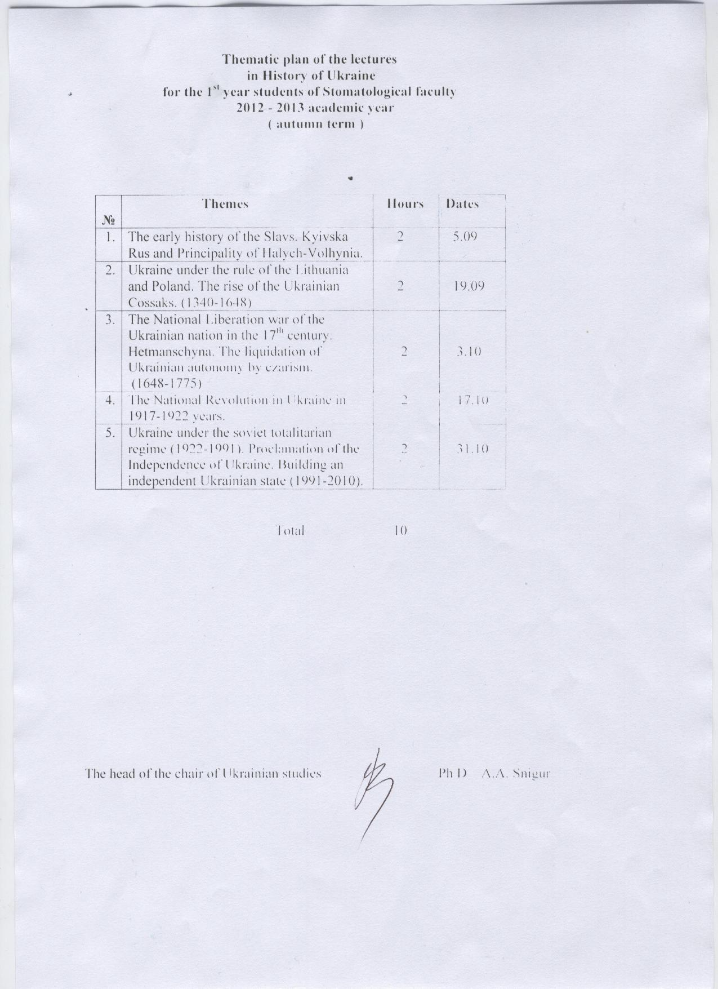
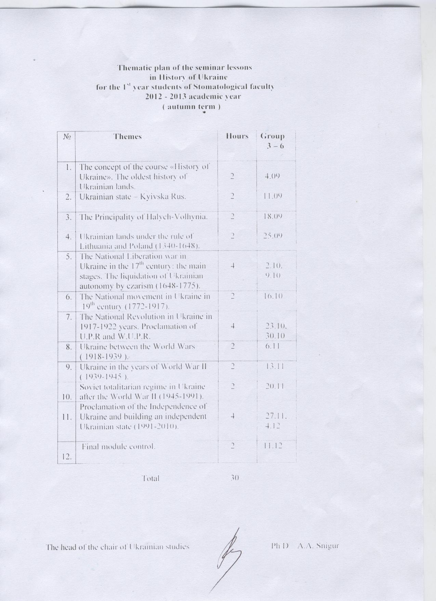

SCHEDULE OF PRACTICAL CLASSES FOR DENTISTRY MEDIUM
1st SEMESTER 2012/2013
LATIN LANGUAGE AND MEDICAL TERMINOLOGY

№ | Theme | h.
1. | Short history of the Latin language. The alphabet. Vowels and consonants. Pronunciation. Diphthongs. | 2
2. | The accent. Length and brevity of the syllable. | 2
3. | Review of the Latin Nouns. Declensions. Formation of anatomical terms (Sn-Sg). Introduction to the anatomical nomenclature. | 2
4. | Review of the Latin Adjectives. Two groups. Formation of anatomical terms (Sn-An). | 2
5. | Anatomical terms with different kinds of modifiers. Test. | 2
6. | The 1st declension of Nouns. The Greek Nouns of the 1st declension. Prepositions (Acc., Abl.) | 2
7. | The 2nd declension of Nouns. The masculine and neutral genders. | 2
8. | The 1st and 2nd declension Adjectives. | 2
9. | Test. | 2
10. | The 3rd declension of Nouns. General information. Three types of Nouns. | 2
11. | The 3rd declension of Nouns. The masculine gender. Exeptions. | 2
12. | The 3rd declension of Nouns. The feminine gender. Exeptions. | 2
13. | The 3rd declension of Nouns. The neutral gender. Exeptions. | 2
14. | The 3rd declension of Nouns. Irregular Nouns. Exeptions. | 2
15. | The 3rd declension Adjectives. | 2
16. | The degrees of comparison of Adjectives. | 2
17. | The 4th declension of Nouns. The 5th declension of Nouns. Exeptions.
18. | Final test. | 2
 | Total | 36
SCHEDULE OF INDUVIDUAL WORK FOR DENTISTRY MEDIUM
1st SEMESTER 2012/2013.
LATIN LANGUAGE AND MEDICAL TERMINOLOGY
Мodule 1

№№ | Theme | Г h.
 | Short history of the Latin language. The alphabet. Vowels and consonants. Pronunciation. Diphthongs. | 1,5
 | The accent. Length and brevity of the syllable. | 1,5
 | Review of the Latin Nouns. Declensions. Formation of anatomical terms (Sn-Sg). Introduction to the anatomical nomenclature. | 1,5
 | Review of the Latin Adjectives. Two groups. Formation of anatomical terms (Sn-An). | 1,0
 | Anatomical terms with different kinds of modifiers. | 1,0
 | The 1st declension of Nouns. The Greek Nouns of the 1st declension. The Verb “sum, esse”. Prepositions (Acc., Abl.) | 1,5
 | The 1st declension Nouns. | 1,5
 | The 2nd declension Nouns. The masculine and neutral genders. | 1,5
 | The 1st and 2nd declension Adjectives. The Past participle passive. Suffixes. | 1,5
 | The 3rd declension Nouns. Three types of Nouns. The masculine gender. Suffixes. | 1,5
 | The feminine gender. Exeptions. Suffixes. | 1,5
 | The neutral gender. Exeptions. Suffixes. | 1,5
 | The peculiarities of declining some 3rd declination Nouns. | 1,5
 | The 3rd declension Adjectives. Suffixes. The Present participle active. | 1,5
 | The degrees of comparison of Adjectives in medical terminology. | 1,5
 | The 4th declension of Nouns. The 5th declension of Nouns. Exeptions. | 1,5
 | Induvidual work | 1,0
 | Total | 24
THEMATIC AND CALENDAR SCHEDULE OF MEDICAL BIOLOGY COURSE LECTURES, PRACTICES, INDEPENDENT WORKS IN THE 2012-2013 ACADEMIC yEAR FOR STUDENTS OF DeNTISTRY FACULTY (eNGLISH MEDIUM)

MODULE 1. Biological features of human vital activity
Content module 1. “Molecular-cellular level of life organization”
Lectures
№ | Topic | Hours | Date
1. | Introducing to Medical Biology. General description of life. A man in the system of nature. Cell level of living things organization. Hereditary apparatus of eukaryotic cell and its functioning. Genetic information and it’s realization in the cell. | 2 | 3.09-14.09
 | Total | 2

Practices
№ | Topic | Hours | Date
1. | Levels of living matter organization. Optical systems in biological investigations. | 2 | 3.09-7.09
2. | Cell membranes. Transport across the cell surface membrane (plasmolemma). | 2 | 10.09-14.09
3. | Cell morphology. Structural components of the cytoplasm. | 2 | 17.09-21.09
4. | Chromosomes morphology. Human karyotype. | 2 | 24.09-28.09
5. | Characteristic of nucleic acids. | 2 | 1.10-5.10
6. | Genes structure in pro- and eukaryotes. Structural, regulatory, tRNA and rRNA genes. | 2 | 8.10-12.10
7. | The organization of the information flow in cell. Regulation of genes expression. | 2 | 15.10-19.10
8. | Cell cycle. Forms of reproduction. | 2 | 22.10-26.10
9. | Biological features of human reproduction. Gametogenesis. Meiosis. Impregnation. | 2 | 29.10-2.11
10. | Control of the module 1 “Biological features of human vital activity”. | 2 | 5.11-9.11
 | Total | 20

Independent work
№ | Topic | Hours
1. | Preparing for practical classes – theoretical preparing and practical experience. | 10
2. | Topics, which are not included to the plan of academic practical classes.
2.1 | The organization of the way of biological information and energy flow in cell. | 1
2.2 | Life of cells outside the organism. Cell cloning. | 1
3. | Preparing of the control of the learning module 1 | 3
 | Total | 15

MODULE 2. Organism level of organization of the alive. Basis of human genetics
Lectures
№ | Topic | Hours |  | Date
Content module 2. Basic principles of heredity and variability
2. | Organism level of the genetic information realization. Gene's interaction and manifestation at the different types of inheritance. Linkage inheritance. Variation in human as life property and genetic phenomenon. | 2 | 17.09-28.09
Content module 3. Methods of the human inheritance investigation. Hereditary diseases. Biology of individual development
3. | The basic principles of human genetics. Human hereditary diseases and methods of their diagnostics. | 2 |  | 1.10-12.10
 | Total | 4

Practices
№ | Topic | Hours | Date
Content module 2. Basic principles of heredity and variability
11. | Human Genetics peculiarity. Heredity laws and traits expression in Human organism (monohybrid and polyhybrid inheritance). Phenomena of pleiotropy. | 2 | 12.11-16.11
12. | Allelic and non-allelic gene’s interactions. Multiple alleles. Genetic of blood groups. | 2 | 19.11-23.11
13. | Linkage inheritance. Sex genetics. | 2 | 26.11-30.11
14. | Variability of the organisms, its forms and manifestation. | 2 | 3.12-7.12
 | Total | 8
Content module 3. Methods of the human inheritance investigation. Hereditary diseases. Biology of individual development
15. | The basic principles of human genetics. Cytogenetic and biochemical analysis of the human being and its value for gene's and chromosomal diseases diagnostics. | 2 | 10.12-14.12
16. | Study of twins. Genealogy of human as the method of human inheritance investigation. | 2 | 17.12-21.12
17. | Dermatoglyphics as the method of human inheritance investigation. Genetic characters of human populations (Hardy-Weinberg law). | 2 | 24.12-28.12
18. | Practical skills of content modules 2 and 3.  “Basic principles of heredity and variability,  Methods of the human inheritance investigation. Hereditary diseases”. | 2 | 10.01-16.01
19. | Peculiarities of prenatal period of human development. Pre-conditions of congenital developmental anomalies. | 2 | 17.01-23.01

Independent work
№ | Topic | Hours
MODULE 2. Organism level of life organization. Basis of human genetics.
Content module 2. Basic principles of heredity and variety
1. | Preparing for practical classes – theoretical preparing and practical experience. | 3
2. | Topics, which are not included to the plan of academic practical classes.
2.1 | Genetic maps. Methods of the human chromosomes mapping. The modern state of human genome investigation. | 3
2.2 | Genetic danger of surrounding pollution. The meaning of antimutagens and comutagens. | 3
 | Total | 9
II semester
Practices
№ | Topic | Hours | Date
20. | Postnatal period of human development. | 2
21. | Control of the module 2 “Organism level of life organization. Basis of human genetics” | 2
 | Total | 4

Independent work
№ | Topic | Hours
1. | Preparing for practical classes – theoretical preparing and practical experience. | 3
2. | Preparing of themes, which don’t in plan of auditory classes.
2.1 | Genetic engineering. Biotechnology. Concept about gene therapy. | 1
2.2 | Methods of the human genetics: dermatoglyphics, immunologic, somatic cell’s hybridization. | 1
2.3 | Aging as the finishing stage of human ontogeny. Theories of ageing. Concepts about biofields, biorhythms and their medical importance. | 1
3. | Practical skills of content modules 2 and 3. | 2
4. | Preparing of the control of the learning module 2 | 3
 | Total | 11

MODULE 3. MODULE 3 "Population-species, biogeocenotic and biospheric levels of life organization"

Content module 4-7. Medical and biological basis of parasitism.

Lectures
№ | Topic | Hours | Date
Content module 4-7. Medical and biological basis of parasitism.
4. | Human ecology. Medical and biological basis of parasitism. Protozoa are human parasites. Medical Helmintology. Flat worms are human parasites. | 2
5. | Round worms as human parasites. Medical Arachnoentomology. Arthropods are activators and vectors of infections and invasions. | 2
 | Total | 4

Practices
№ | Topic | Hours | Date
Content module 4. Medical Protozoology

22. | Phylon Sarcomastigophora, Classis Lobozea. Phylon Ciliophora. Representatives of the Classis Rimostomatea are human parasites. | 2
23. | Representatives of the Classis Zoomastigophora are human parasites. | 2
24. | Phylon Apicomplexa. Representatives of the Classis Sporozoa are human parasites. | 2
Content module 5. Medical Helminthology

25. | Phylon Plathelmintes. Classis Trematoda: liver, cat’s, lancet-like and lung flukes. | 2
26. | Classis Cestoidea: beef, pork, dwarf tapeworms, Echinococcus – are activators of human diseases. | 2
27. | Phylon Nemathelmintes. Classis Nematoda: large intestinal roundworm, pinworm (seatworm), whipworm are activators of human diseases. | 2
28. | Phylon Nemathelmintes. Classis Nematoda: Ancylostoma duodenale, Strongiloides stercoralis, Trichinella spiralis are activators of human diseases. | 2
29. | Practical skills of content modules 4 and 5 “Medical Protozoology” and “Medical Helminthology” | 2
Content module 6. Medical Arachnoentomology

30. | Phylon Arthropoda. Classis Arachnoidea. Ticks (Acarina) are activators and vectors of human diseases. | 2
31. | Classis Insecta: lice (Anoplura), flees (Aphaniptera), Diptera are activators and vectors of human diseases. | 2
Content module 7. Correlation between individual and historical development. Biosphere and human

32. | Phylogenesis of main organ systems of Vertebrates. | 2
33. | Biosphere as a system which keeps up global existence of mankind. Human ecology. | 2
34. | Synthetic theory of evolution. Population structure of mankind. | 2
35. | Control of the module 3 “Population-species, biogeocenotic and biospheric levels of life organization” | 2
 | Total | 28

Independent work
№ | Topic | Hours
Content module 4. Medical and biological basis of parasitism.
Medical Protozoology
1. | Preparing for practical classes – theoretical preparing and practical experience. | 3
2. | Preparing of themes, which don’t in plan of auditory classes.
2.1 | Methods of laboratory diagnosis of diseases caused by protozoa parasites. | 3
 | Total | 6
Content module 5. Medical Helminthology
1. | Preparing for practical classes – theoretical preparing and practical experience. | 2
2. | Preparing of themes, which don’t in plan of auditory classes.
2.1 | Blood flukes – causative agents of parasitogenic illnesses of man. Agents of metagonimosis and nanophoetosis. | 2
2.2 | Guinea worm (Dracunculus medinensis) and Filaria – agents of human diseases. | 1
 | Total | 5
Content module 6. Medical Arachnoentomology
1. | Preparing for practical classes – theoretical preparing and practical experience. | 2
2. | Preparing of themes, which don’t in plan of auditory classes.
2.1 | Blood sucking insects: characters, importance as the intermediate hosts of helminthes and carriers of human infections. | 1
 | Total | 3
Content module 7. Correlation between individual and historical development. Biosphere and human.
1. | Preparing for practical classes – theoretical preparing and practical experience. | 2
2. | Preparing of themes, which don’t in plan of auditory classes.
2.1 | Origin of man. Human races as reflection of developmental adaptation. | 1
2.2 | Poisonous plants and animals. | 1
3. | Preparing of the control of the learning module 3 | 2
 | Total | 6

Plan of lectures

of the course of “Medical and Biological Physics”

for first-year students of Faculty of Dentistry

in the first semester of 2012/2013 academic year

№ | Topics | Class  duration  (hours) | Date
 | Biophysics of hearing. Biophysical influence of ultrasound, infrasound, vibrations, noise and their usage in diagnostics and treatment. | 2 | 24.09
 | Principles of biological rheology. Rheological properties of biological liquids. Physical principles of hemodynamics. Mechanical properties of biological objects. | 2 | 22.10
 | Transport of substances through biological membranes. Bioelectrical potentials. | 2 | 19.11
In total |  | 6

Plan of laboratory and practical classes

of the course of “Medical and Biological Physics”

for first-year students of Faculty of Dentistry

in the first semester of 2012/2013 academic year

№ | Topics | Class  duration  (hours)

Module 1.

Mathematical processing of medical and biological information
1 | Basics of differential calculus. | 2
2 | Basics of integral calculus. | 2
3 | Concept of differential equations. | 2
4 | Elements of the theory of probability. | 2
5 | Elements of mathematical statistics.  Laboratory work. Analysis of distribution of investigated criterion and determination of statistical characteristics. | 2
6 | Final module № 1 (topics 1-5). | 2
Module 2.
Basics of biophysics
7 | Elements of biomechanics.  Laboratory work. Study of mechanical properties of biological objects. | 2
8 | Elements of biomechanics.  Laboratory work. Determination of coefficient of elasticity of bone tissue. | 2
9 | Elements of biophysics of hearing.  Laboratory work. Study of spectral characteristic of the ear on the hearing threshold. | 2
10 | Infrasound. Ultrasound. Vibrations.  Laboratory work. Study of parameters of biological objects by ultrasonic location method. | 2
11 | Principles of biorheology.  Laboratory work. Study of rheological properties of biological liquids. | 2
12 | Principles of biorheology.  Laboratory work. Determination of the coefficient of viscosity of liquid by capillary viscosimeter. | 2
13 | Laboratory work. Determination of surface tension coefficient of liquids by stalagmometer. | 2
14 | Principles of hemodynamics.  Laboratory work. Physical principles of investigation of hemodynamics parameters. | 2
15 | Laboratory-practical class. Study of principles of thermodynamics of open biological systems. | 2
16 | Elements of biophysics of membrane processes.  Laboratory-practical class. Study of structure and functions of biological membranes. | 2
17 | Laboratory-practical class. Study of mechanisms of resting and action membrane potentials generation. | 2
18 | Final module № 2 (topics 7-15). | 2
In total |  | 36

Self-study plan

of the course of “Medical and Biological Physics”

for first-year students of Faculty of Dentistry

in the first semester of 2012/2013 academic year

Module 1. Mathematical processing of medical and biological information

№ | Topics
1. | To become proficient in calculation of derivatives of simple and compound functions.
 | To become proficient in differentiation of function of one variable, partial derivatives and differentials of function of two and more variables and complete differential.
2. | To become proficient in method of integration by substitution and by parts.
3. | To become proficient in solving of differential equations.
4. | To become proficient in using of theorems of addition and multiplication of probabilities for tasks solution.
5. | To learn how to use the methods of mathematical statistics for solution of medical-biological tasks.
 | Preparation for written test.
 | Individual work – preparation of scientific literature review.
 | In total – 18 hours for self-study

Module 2. Basics of Biological Physics
6. | To learn haw to explain undamped and damped vibrations in biological systems.
7. | To become proficient in working with clinical audiometer.
 | To estimate and interpret the results of study of spectral sensitiveness of the ear on the hearing threshold.
8. | To become proficient in the interpreting of diagrams of extension and compression and in determination of main parameters of tissues elastic properties.
9. | To become proficient in determination of coefficient of surface tension.
10. | To become proficient in determination of viscosity coefficient of liquids.
11. | To familiarize oneself with rheology properties of blood.
12. | To become familiar with thermodynamics method of study of medical-biological systems.
 | To become familiar with biophysical principles of reception (visual reception).
13. | To explain the nature of generation of concentration potential.
14. | To become proficient in making of electric circuit and determination of electromotive force of concentration element by compensative method.
15. | To become proficient in working with the computer program and to study the change of action potential.
 | Preparation for tests (module 2).
 | Individual work – preparation of review of scientific literature in the abstract form (one of mentioned below items).
 | In total – 15 hours for self-study

CALENDAR AND THEMATIC SCHEDULE OF LECTURES
on medical chemistry for the 1st year students of dentistry faculty
during the autumn term of 2012 – 2013 academic year
Groups 3-6
To p i c s a n d c o n t e n t s o f l e c t u r e s Number
Date of hours
14.09.2012
Coordination compounds formation in biological liquids. Complexonometry.
The chemistry of bio-elements. The general knowledge of bio-elements, their
biochemical role and their compounds using in medicine.
2
28.09.2012 Protolytical equilibrium in biologiocal systems. 2
12.10.2012
Thermodynamical and kinetical regularities of biochemical processes
passage. Precipitation and dissolution reactions.
2
26.10.2012 Physics and chemistry of the surfaces phenomena. 2
09.11.2012 The methods of colloidal solutions preparation. Purification and properties of
colloids. Physical chemistry of bio-polymers solutions.
2
Totally: 10
CALENDAR AND THEMATIC SCHEDULE
of practice and laboratory studies on medical chemistry for the 1st year students of dentistry faculty
during the autumn term of 2012 – 2013 academic year
Groups The topic Number
3 4 5, 6 of hours
Date
Thematic module 1. “Acid-Base Equilibrium and the Processes of Coordination Compounds
Formation in Biological Liquids”
07.09 05.09 03.09
The ways of expression concentrations of solutions.
Preparation the solution with known concentration.
3
14.09 12.09 10.09 Colligate properties of solutions. Experimental determination
of the molecular mass of a solute, osmotic concentration of
solutions with the kriometry method
3
21.09 19.09 17.09 The equilibrium and processes with coordination compounds.
Preparation and properties of complex and inner complex
compounds. Complexonometry
3
28.09 26.09 24.09 Bio-elements in medicine and dentistry. Their chemical
properties and biological role
3
05.10 03.10 01.10 Acid-base equilibrium. Calculation and experimental
determination of the рН of biological liquids. Protolytical
processes in living organisms.
3
12.10. 10.10 08.10 Properties of buffer solutions and their role in biological
systems. Preparation of buffer solutions. Determination of the
buffer capacity.
3
19.10 17.10 15.10 The basic principles of the volumetric analysis. Acid-base
titration. Precipitation and dissolution reactions.
3
Thematic module 2. “Heterogeneous equilibrium in biological liquids”
26.10 24.10 22.10 Thermodynamical and kinetical regularities of biochemical
processes passage.
3
02.11 31.10 29.10 Measuring the electrical driving force of electrochemical
elements and electrodes potentials.
3
09.11 07.11 05.11 Adsorptive processes and ions exchange in bio-systems.
Chromatography.
3
16.11 14.11 12.11 Preparation, purification and properties of colloidal solutions. 3
23.11 21.11 19.11 Electrolytic coagulation of colloids. Physical chemistry of biopolymers
solutions.
3
30.11 28.11 26.11 The final control of the acquirement the Module “the basis of
medical chemistry ”
4
Totally: 40

Calendar and thematic plan
of lectures of “Bioorganic chemistry ” for the first year students
of the Faculty of Dentistry
(Autumn semester of 2012/2013 educational year)

№ | Theme of lecture | Hours | Date
1 | Bioorganic chemistry. Classification of the chemical reactions. Reactivity of the hydrocarbons. Hydroxy derivatives of the hydrocarbons. Thioles. Amines. | 2 | 09.09
2 | Carbonyl-containig compounds. Carboxylic acids. Lipids. | 2 | 21.09
3 | Heterofunctional compounds. Proteinogenous aminoacids. Peptides. Proteins. | 2 | 05.10
4 | Heterocyclic compounds. Alkaloids. Nucleic acids. | 2 | 19.10
5 | Carbohydrates | 2 | 02.11
 | Total hours | 10

thematic plan
of out-classes work of “Bioorganic chemistry ” for the first year students of the Faculty of Dentistry
(Autumn semester of 2012/2013 educational year)

№ | Theme | Hours
1 | Preparation for the practical classes:  To draw the formula of the structural and spatial (stereo) isomers of bioorganic compounds, the structure of biopolymers and their structural components, analyse the reactivity of carbohydrates, lipids, amino acids, which ensure their functional properties and metabolic transformation. | 10
2 | Be able to interpret the results of laboratory studies of the biological liquids on contents of glucose, ketone bodies, pentoses, amino acids, peptides and proteins. | 5
3 | Analyse the biochemical functions of vitamins | 4
4 | Individual task – creation of schemes: classification of the organic compounds, the structure of proteins, carbohydrates, nucleic acids | 2
5 | Preparation for the final module | 4
 | Total hours | 25

Calendar and thematic plan
of practical work of “Bioorganic chemistry ” for the first year students
of Faculty of Dentistry

(Autumn semester of 2012/2013 educational year)

№ | Theme | Hours | Date
1 | Introduction. Classification and nomenclature of bioorganic compounds. | 2 | 03.09-06.09
2 | Reactivity of hydrocarbons | 2 | 10.09-13.09
3 | Mono- and poly-alcohols, ethers and thioanalogs. | 2 | 17.09-20.09
4 | Phenols, amines. Acidic and basic properties of organic compounds. | 2 | 24.09-27.09
5 | Aldehydes and ketones | 2 | 01.10-04.10
6 | Carboxylic acids and their derivatives. | 2 | 08.10-11.10
7 | Control work “Hydrocarbons and homofunctional derivatives of bioorganic compounds” | 2 | 15.10-18.10
8 | Hydroxy- and oxo-acids. | 2 | 22.10-25.10
9 | Amino phenols, amino alcohols, amino acids. Derivatives of the sulfanilic acid. | 2 | 29.10-01.11
10 | Saponifiable lipids | 2 | 05.11-08.11
11 | Non saponifiable lipids | 2 | 12.11-15.11
12 | Biologically active 5-membered heterocyclic compounds | 2 | 19.11-22.11
13 | Biologically active 6-membered heterocyclic compounds | 2 | 26.11-29.11
14 | Biologically active fused heterocyclic compounds. Alkaloids. | 2 | 03.12-06.12
15 | Control work “Biologically active heterofunctional and heterocyclic compounds. Lipids” | 2 | 10.12-13.12
16 | Monosaccharides. | 2 | 17.12-20.12
17 | Di- and polysaccharides | 2 | 24.12-27.12
18 | Proteinogenous aminoacids. Peptides. Proteins. | 2 | 10.01-11.01
19 | Nucleic acids. Nucleotidic enzymes | 2 | 14.01-17.01
 | Total hours | 38
 | Final module control | 2 | 21.01-24.01

Plan of the practices on human anatomy for the students of dentistry

faculty in 1st semester of 2012/2013 studying year

Topic |  |  |  |  |  |  |  |  |  | Групи, дата
№ |  |  | 1, 2 |  | 3 – 4 |  |  | 5-6
1. | Anatomical terminology.Fundamental planes and axes in the body. General features of the vertebrae. Cervical, thoracic and lumbar vertebrae. Sacrum, coccyx, ribs, sternum. |  | 03.09 |  | 03.09 |  |  | 04.09
2. | Bones of skull. Frontal, parietal, occipital ,sphenoid, bones. |  | 06.09 |  | 06.09 |  |  | 06.09
3. | Sphenoid and temporal bones. |  | 10.09 |  | 10.09 |  |  | 11.09
4. | Bones of face. Maxilla and mandibula. |  | 13.09 |  | 13.09 |  |  | 13.09
5. | Orbit. Nasal cavity. |  | 17.09 |  | 17.09 |  |  | 18.09
6. | Base of skull. Temporal fossa, infratemporal fossa, pterygopalatine fossa. |  | 20.09 |  | 20.09 |  |  | 20.09
7. | Bones of upper limb. |  | 24.09 |  | 24.09 |  |  | 25.09
8. | Bones of lower limb. |  | 27.09 |  | 27.09 |  |  | 27.09
9. | Summary lesson 1. Bones of аxial and аppendicular skeleton. |  | 01.10 |  | 01.10 |  |  | 02.10
10 | General arthrology. |  | 04.10 |  | 04.10 |  |  | 04.10
11 | Articulation of vertebral column and thorax. Articulations of skull. Temporomandibular joint. |  | 08.10 |  | 08.10 |  |  | 09.10
12 | Articulations of upper limb. |  | 11.10 |  | 11.10 |  |  | 11.10
13 | Articulatins of lower limb. |  | 15.10 |  | 15.10 |  |  | 16.10
14 | Summary lesson 2. Articulations of аxial and аppendicular skeleton. |  | 18.10 |  | 18.10 |  |  | 18.10
15 | Muscles and fasciae of back. |  | 22.10 |  | 22.10 |  |  | 23.10
16 | Muscles and fasciae of chest and abdominal wall. Diaphragm. Inguinal canal. |  | 25.10 |  | 25.10 |  |  | 25.10
17 | Muscles and fasciae of head. |  | 29.10 |  | 29.10 |  |  | 30.10
18 | Muscles of neck. Cervical fascia. Topography. |  | 01.11 |  | 01.11 |  |  | 01.11
19 | Muscles of shoulder girdle and arm. Muscles of hand. |  | 05.11 |  | 05.11 |  |  | 06.11
20 | Topography and fasciae of upper limb. |  | 08.11 |  | 08.11 |  |  | 08.11
21 | Muscles of pelvis, thigh and leg. Muscles of foot. |  | 12.11 |  | 12.11 |  |  | 13.11
22 | Topography and fasciae of lower limb. |  | 15.11 |  | 15.11 |  |  | 15.11
23 | Summary lesson 3. Muscular system. |  | 19.11 |  | 19.11 |  |  | 20.11
24 | Total check of module 1 “Locomotor system”. |  | 22.11 |  | 22.11 |  |  | 22.11
25. |  | Oral cavity. Tongue, palate, salivary glands. |  | 26.11 |  | 26.11 | 27.11
26. |  | Teeth. |  | 29.11 |  | 29.11 | 29.11
27. |  | Pharynx, esophagus, stomach. |  | According to depart, schedule
28. |  | Small and large intestine. |  | 03.12 |  | 03.12 | 04.12
29. |  | Liver. Pancreas. Spleen. |  | 06.12 |  | 06.12 | 06.12
30. |  | Peritoneum. |  | 10.12 |  | 10.12 | 11.12
31. |  | Summary lesson 4. Digestive system. |  | 13.12 |  | 13.12 | 13.12
32. |  | External nose. Nasal cavity. Paranasal sinus. Larynx. Thyroid and parathyroid glands.
33. |  | Trachea. Bronchi. Lungs. Pleura. Mediastinum. Pleura. Summary lesson 5. “Respiratory system”. |  | 17.12 |  | 17.12 | 18.12
34. |  | Kidneys. Urinary bladder. Ureters. Female urethra. Adrenal glands. Summary lesson 6. “Urinary system”. |  | 20.12 |  | 20.12 | 20.12
35. |  | Male reproductive organs. |  | 24.12 |  | 24.12 | 25.12
36. |  | Female reproductive organs. Mammary gland. Perineum. Summary lesson 7. “System of generation”. |  | 27.12 |  | 27.12 | 27.12
37. |  | Anatomy of immune organs. Thymus, bone marrow, spleen, lymphatic nodes, tonsils.  Anatomy of endocrine glands. Thyroid and parathyroid glands.  Adrenal gland. Pituitary gland. Pineal body. Endocrine part of pancreas.  Summary lesson 8. “Immune and endocrine systems”. |  | 31.12 |  | 31.12 | According to depart, schedule
38. |  | Anatomy of spinal cord.  Summary lesson 9. “Anatomy of spinal cord”. |  | 10.01 |  | 10.01 | 10.01
39. |  | Embryogenesis of brain. Anatomy of medulla oblongata and pons. |  | 14.01 |  | 14.01 | 15.01
40. |  | Anatomy of cerebellum. 4th ventricle. Rhomboid fossa. |  | 17.01 |  | 17.01 | 17.01
100

HISTOLOGY LECTURE SCHEDULE
for Foreign Students, Faculty of Dentistry, 1st year. Autumn semester. Academic year 2012-2013.

№ | Topic of the lecture | Groups/Date
 |  | 1-7 | 8-14 | 1 for. ukr. | 2 for. rus. | 3-5 for. eng.
1. | Introduction to Histology, Cytology and Embryology. Cytology. Organelles and Inclusions. Nucleus of the Cell. Cell division. Cell aging and cell death. | 05.09 | 13.09 | 12.09 | 05.09 | 13.09
2. | The Basics of General Embryology. Development of Higher Mammals and Human development | 19.09 | 27.09 | 26.09 | 19.09 | 27.09
3. | Concept of Tissues. Covering Epithelium. Tissues of internal environment. Morphology of Blood. | 03.10 | 11.10 | 10.10 | 03.10 | 11.10
4. | Special tissues. Muscular and Nervous tissues. | 17.10 | 25.10 | 24.10 | 17.10 | 25.10
5. | Nervous system and Organs of Senses. | 31.10 | 08.11 | 07.11 | 31.10 | 08.11

INDEPENDENT WORK

for 1st year Foreign Students, Faculty of Dentistry,

Autumn semester. Academic year 2012-2013.

1. | History of the development of Histology, Cytology and Embryology. Histology in Ukraine. | 2 hours
2. | Microscope. Microscopic devices. Histological techniques. | 2 hours
3. | Modern methods of Histological, Cytological and Embryological Investigations. | 2 hours
4. | Intercellular Contacts, their Types, Intercellular Interactions. | 2 hours
5. | Chromatin and Chromosomes. Morphology and chemical composition. Caryotype. Ploidity. | 2 hours
6. | Life and cell cycle, their characteristics. Apoptosis, its biological and medical meaning. Cell aging and cell death. | 2 hours
7. | Conception of extracorporal fertilization, its medical and social meaning. | 2 hours
8. | The Animal Cloning. | 2 hours
9. | Objective regularity of the Origin and Evolution of the Tissues. Differentiation, determination. Regeneration. | 2 hours
10. | Hemogram. White blood cells account. Age changes of the Blood. Lymph Characteristics. | 2 hours
11. | Embryonic hemopoesis (development of blood). Peculiarities of yolk sac and hepatic hemopoesis. Modern model of hemopoesis. | 2 hours
12. | Postembryonic hemopoiesis. Conception of colonies-making units. | 2 hours
13. | Histogenesis, Regeneration and Age Changes of Cartilage. | 2 hours
14. | Osteogenesis and Regeneration of the Bone. | 2 hours
15. | Molecular Mechanisms of Contraction of Muscle Fiber. | 2 hours
16. | Mechanisms of Impulse transmitting in Synapses. Nerve Fibers. | 2 hours
17. | Brain barrel. Interneuronal connections. | 2 hours
18. | Histophysiology of the eye. | 3 hours
19. | Histophysiology of the ear. | 3 hours

In total – 40 hours.

